NATIONAL GALLERIES OF SCOTLAND

OPERATIONS

FACILITIES MANAGER MECHANICAL AND ELECTRICAL
FIXED TERM (6 - 12 MONTHS) FULL TIME (Band 5a)

The National Galleries of Scotland (NGS) is home to one the world’s finest collections off art, which ranges from the Middle Ages to the present day. Our spectacular buildings house the world’s greatest collection of Scottish art, and a world-renowned collection of Scottish and international photography, welcoming many visitors to our three principal sites in Edinburgh: the Scottish National Gallery, the Scottish National Gallery of Modern Art and the Scottish National Portrait Gallery. The National Galleries of Scotland aims to preserve, display and augment the collections for the enjoyment and education of the widest possible public and to maintain NGS as a centre of excellence.

This is an exciting period of renewal for NGS, as we move forward with our engaging strategic vision that puts our audience at the heart of what we do. We’re making it our mission to broaden our impact, matching our rich collections, expertise and creativity to the needs and wants of our visitors. We’re finding new ways to connect with more people, and creating an innovative, inclusive organisation that can meet the challenges of our ever-evolving world.

‘Art for Scotland: Inspiration for the world’ is Our Vision. Inclusive, original and ambitious – we will make the national collection accessible to all and inspire curiosity across the world.

At NGS we are committed to looking at how we operate as well as how we engage with our visitors and communities. We want to play our part in tackling the Climate Emergency. We will ensure Equality, Diversity and Inclusion (EDI) is embedded across our organisation, ensuring everyone feels a sense of belonging and can be themselves.

Role Purpose:

We are seeking to appoint an experienced Mechanical and Electrical Engineer as one of our Facilities Management team to manage the existing mechanical and electrical building services, including security and fire alarm systems and to lead the electrical and security systems improvement projects. The post is responsible for all matters relating to building services, including planned and response maintenance activities by contractors, ensuring compliance with relevant statutory instruments.

This role reports into the Head of Estates who sits in the Chief Operating Office Leadership Team.

The Chief Operating Office includes our entire Operations team, consisting of Health & Safety, Security and Visitor Services (SVS), Procurement and Legal, working together with our Finance, Information Technology, Human Resources and Estates Teams.

We work together and collaborate across NGS and with external partners to ensure our collection and people are safe and secure, to deliver operational services that improve our visitor experience and to ensure NGS is a great place for us all to work.

This is an exciting time for the Chief Operating Office within NGS as we continue to develop and implement our 5-year improvement plans, plan to open the newly established gallery spaces at the Scottish National Gallery and input to the development of the major new collection facility at Granton – The Art Works (TAW).

https://www.nationalgalleries.org/art-and-artists/features/art-works

The main responsibilities of this role will be to:
- ensure maintenance works and estates capital projects are carried out within full compliance of robust processes to ensure the integrity, safety of our staff and environmental conditions for our collection are maintained throughout
- appoint and manage the building services planned and response maintenance contracts for allocated mechanical and electrical building services for our heritage buildings
- assist in the development and manage the planned preventive maintenance and replacement plan for our electrical and security installations.

Structure:

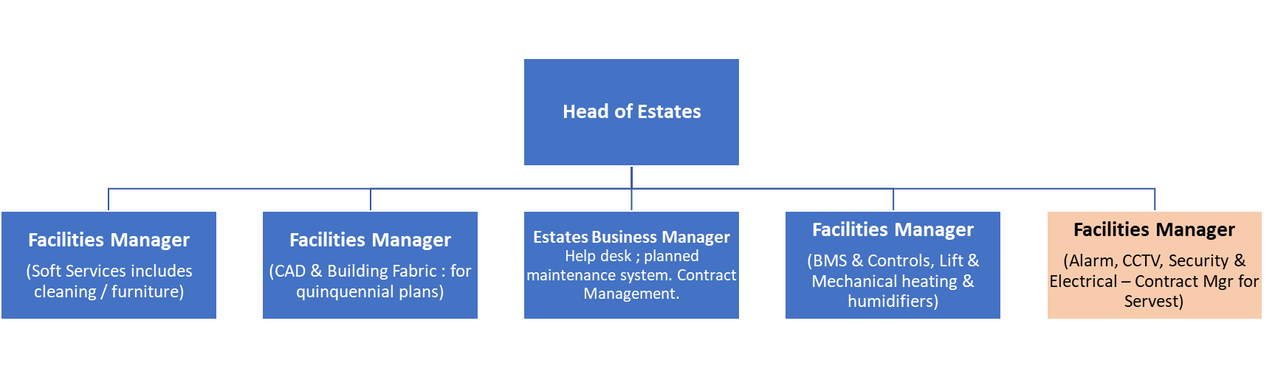
The role reports to the Head of Estates in the Chief Operating Office. This is one of 4 Facilities Managers in the Estates Team (2 Building Services disciplines).

Duties and Responsibilities:
Facilities Management
- The procurement and supervision of mechanical and electrical (M&E) related projects, maintenance and repair works, including daily inspections to ensure adherence to specification and compliance with health and safety and statutory requirements.
- The co-ordination and updating of project related building services records covering as built drawings, plant asset records, maintenance manuals and planned routine maintenance works, as well as general policy and operational procedures.
- The preparation of contract documentation for all M&E projects, repairs and services support works throughout the estate, and/or liaison with outside support consultants.
- The control and direct supervision of the computerised M&E Planned Maintenance system, liaison with service contract staff and ensure that the database of service records is kept up to date.
- Ensuring that accurate records are kept of all breakdowns through the computerised helpdesk system and that all faults are rectified in accordance with the agreed contracts.
- To operate the Building Management System to ensure plant is operating efficiently and that environmental requirements are being met.
- Liaison with and advice to curatorial staff and artists on technical support matters relating to exhibition installations, environmental conditions and associated lighting.
- Take an active part in reducing our carbon footprint through our activities. This includes better use of the Building Management Systems, new low energy technologies and controls.
- Acting as temporary cover to the other estates Facilities Managers and the Head of Estates in their absence on leave/sickness, etc.
Strategic Input
- Make recommendations on the sequence of improvement projects in response to the mechanical and electrical systems review, assisting in the evaluation of condition and remaining lifecycle planning.
Budget Management & Continuous Improvement
- Responsible for c£200 to £300k of estates capital projects
- Within the COO, each team is developing their own 5-year improvement programme of work. This role will be expected to develop, co-ordinate and implement the improvement programme for the ongoing management and maintenance of the Security, Fire Alarm and Electrical installations.
- Provide recommendations on how continuous improvement can be established in the Estates team to help improve our operating efficiencies, the visitor experience and colleague engagement.
Documentation Management
- The role will be required to keep up to date all systems plans.
Key Internal Relationships
- This role interacts with all the rest of the Estates team, the Director of Operations, the Head of Security, the Chief Technology Officer, Health and Safety Manager and specialists in the Conservation Department.
Key External Relationships
- Responsible for appointing and managing specialist consultants.
- Responsible for appointing and managing a series of specialist contractors and to deliver on our fabric improvement plans.

Skills & Experience
It is an essential requirement that the successful candidate has demonstrable experience in the knowledge, skills and experience outlined below:

Essential
- Electrical Engineer or Building Services Engineer with experience of maintaining and managing Electrical and mechanical systems including distribution, emergency lighting and portable appliance testing (Degree qualified, minimum 5 years' experience, electrical bias preferred).
- Experience of maintaining and managing fire (detection & safety) and security systems (minimum 5 years' experience).
- Experience of maintaining and managing building services (minimum 5 years' experience)
- Experience of initiating, planning, scoping, and implementing a series of systems improvement projects – ideally with similar heritage buildings.
- Experience of leading and managing specialist contractors.
- Contract Management (including contract administration experience).
- Dealing with all aspects of estates Health and Safety in building improvement projects, including Risk Assessment and Fire Management of building improvement projects.
- Problem solver.
- Technical skills and experience in facilities management.
- Procurement experience.
- The ability to write specifications and prepare contracts.
- Understanding of the challenges and opportunities of operating popular, free visitor attractions.
- Understanding of the challenges and constraints of maintaining iconic listed buildings at multiple sites with external grounds and art works.
- Understanding of trends and best practice in the relevant technical areas.
- Strong communication skills.

Desirable

- Membership of BIFM or CIBSE or other professional body
- Experience in a similar role in an Arts environment.
- Knowledge of BS5454/ BS EN 16893.
- Experience of CMMS/CAFM Software (currently Qube Planet FM Enterprise).
- Experience of commissioning building services.
- A good knowledge of Fire & Security Systems including CCTV, Access Control and alarm systems.
- Experience on maintaining buildings electrical installations, lighting, distribution and UPS systems.
- Up to date knowledge of current regulations and statutory requirements with regards to electrical systems and testing.
- Working knowledge of exhibition & galleries lighting.
- Computer Aided Design experience.

Qualifications

- Degree qualified, with relevant professional qualification as an electrical engineer or building services engineer

- BS 7671:2018 Requirements for Electrical Installations: IET Wiring Regulations 18th Edition

SUMMARY TERMS AND CONDITIONS

Salary £33,314 - £36,496

Hours 42 hours per week inclusive of lunch breaks

Annual Leave 25 days per annum and 11.5 public and privilege holidays FTE, pro-rata depending on hours

Pension Civil Service pension provisions enables the National Galleries of Scotland to offer a choice of occupational and stakeholder pensions, giving you the flexibility to choose the pension that suits you best.

The closing date for completed applications is Sunday 12 December 2021

Please note that the successful candidate will be subject to
Basic Disclosure Scotland security clearance.

