 | Job Description | 2020

Role: Business Manager | Region / Department: Edinburgh & East
Reports to: General Manager | Pay Band: Grade 5 Upper, Minimum rate £41,550 Fully competent rate £46,167
Location: Newhailes | Type of Contract: Permanent / Full Time
Note
The post is subject to the standard terms and conditions provided with the application pack and the following special terms also apply:
available to work weekends, no evening work planned (unless arranged for a specific function).
Application closing date: 1 October 2021

Scope of role and responsibilities
The Business Manager is effectively a performance management (KPIs, revenues and costs), business planning, resource planning, business analysis, and compliance manager working on behalf of the General Manager.

The role reflects the devolved emphasis within the NTS and ensuring business units are optimising their use of resources, their efficiencies and revenue performance. It has specific responsibility, under the leadership of the General Manager for the coordination, production and subsequent monitoring and assessment of business plans (Annual Operating Plans) and developing and producing management information. They will lead corporate governance and policy within the Region.

Their key responsibilities cover the following areas:
- Trading performance and customer insight; business analysis
- Employment and payroll management
- Market analysis (competitive, trends)
- Business development appraisals (product, events, capital projects)
- Cost analysis and appraisals (operating costs, supply, project, resources)
- Resource planning (technical services, contractors, internal resourcing)
- Project planning and appraisals (conservation and commercial)
- Process analysis and continuous improvement
- Business planning (AOPs,)
- Commissioning and appointments of contracted services
- Management information and reporting within the Region/Group
- Inventory planning and control: retail, foods services, property supplies.

The Business Manager ensures compliance with corporate governance and policy frameworks. This relates to areas such as schemes of delegation, procurement policies and practice, health and safety policy and general policies (technical, regulatory and statutory, risk management). The Business Manager is therefore a business unit performance management role and corporate compliance role and represents a key appointment in how devolved management in manifested in practice through Regions. The Business Manager may have delegated responsibilities for operational management within properties.

Organisational relationships and management
- Primary responsibilities for business planning and trading performance management, the role therefore requires substantial team activity, leadership and problem solving.
- The Business Manager is the ‘custodian’ of policy, governance and compliance within the business unit, relating to a wide range of issues such as procurement, Health & Safety, Schemes of Delegation, general policy frameworks, planning legislation, and so on.
- As a compliance and governance role, key relationships include Corporate Services and Customer & Cause.

Property planning to deliver conservation and visitor strategies
- Responsibility in coordinating and producing effective annual operating plans: fundamental to the Trust’s ability to deliver conservation and visitor strategies and providing a basis of continuous improvement and performance management across the properties.
- High level of familiarity with the nature and direction of each property is required.
- Whilst decision-making and accountability for outcomes and results rests with the General Managers, the Business Manager is central to both devising plans and solutions and to ensuring plans and outcomes are assessed against their desired aims.

Stakeholder engagement
- The nature of this role is such that it is a key external facing position with contractors, suppliers and partners.
- Internally, Consultancy Services suppliers are also an important stakeholder group, with resource planning, technical advice and planning inputs essential.
- Personally, they seek out and build positive and productive relationships and act as an external networker and advocate for NTS services.

Operational and business management
- The Business Manager is part of the management team within each Region and will participate in general and operational management duties as required.
- This extends to duty management, decision-making, compliance (e.g. H&S, contractor management) and representing NTS.

Health, Safety and the Environment
- The Business Manager undertakes duties under the Health & Safety Policy and specifically for the effective operations of corresponding activity and environments.
- Demonstrate effective oversight of H&S activities relating to all operations in the heritage environment, ensure operational practices reflect them and, guide and advise operational managers accordingly.
- Reflect the Trust’s “Safe System of Work” within activities and through active coordination of procedures in practice through operational staff and managers (Risk Assessment, CoSHH, HACCP and RIDDOR reporting).
- Demonstrate responsibility and accountability that all working practices are in line with the Trust’s “Environmental Policy” and mindful of the Trust’s obligations to minimise the impact on the environment, e.g. through efficient use of water/heat/light, recycling and the disposal of waste, considered use of transport.

Staff and Volunteer Leadership
- Promoting individual and collective responsibility for performance in all activities.
- Coaching property teams and individuals to ensure that they are fully equipped to undertake their duties to the required Trust standards and policies in relation to learning services.

REQUIRED QUALIFICATIONS, SKILLS, EXPERIENCE & KNOWLEDGE
Qualifications
- Graduate or equivalent essential; a post-graduate qualification in business management, finance or marketing highly desirable (e.g. MBA).
- A full driving license for driving in the UK.

Experience
- Direct experience of managing a commercial or trading function where business planning and business performance management are central. This may be within a range of industries (e.g. financial services, retailing, leisure and hospitality, construction)
- Direct experience of developing and implementing business plans within a trading environment.
- Demonstrable experience of supply chain management, procurement, contractor management across capital, professional services and inventory supply.
- Business analysis experience and advanced knowledge and understanding of financial reporting, marketing reporting and systems reporting.

The normal day-to-day duties of this role are such that a criminal record check or membership of the PVG scheme is not required.

Behaviours & Values
As a ‘Grade 5 Upper’, this role would be expected to exhibit the following competencies:

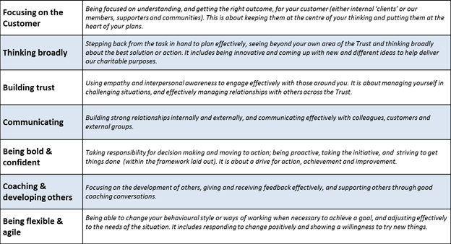

Structure
- The Business Manager is supported by the Regional Office Manager and Business Administrator.
- Central resource including catering and retail support is also provided through Commercial Enterprises & Estates from Head Office.

The Key Responsibilities, Scope of Job, and Required Qualifications, Skills, Experience & Knowledge reflect the requirements of the job at the time of issue. The Trust reserves the right to amend these with appropriate consultation and/or request the post-holder to undertake any activities that it believes to be reasonable within the broad scope of the job or his/her general abilities.

Applications
Interested applicants should forward a completed application form to the People Department (Applications), The National Trust for Scotland, Hermiston Quay, 5 Cultins Road Edinburgh EH11 4DF, by mail or by email via workforus@nts.org.uk, by first post (i.e. 10.00am) on 1 October 2021.

