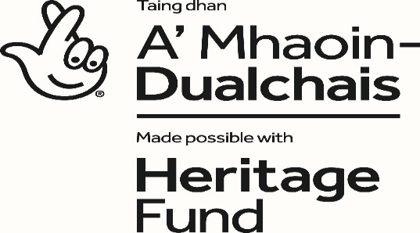
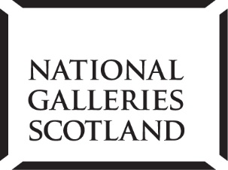

NATIONAL GALLERIES OF SCOTLAND

Learning & Engagement

PROJECT LEARNING OFFICER – CELEBRATING SCOTLAND’S ART (BAND 6)
FULL-TIME 9-MONTH FIXED-TERM (MATERNITY COVER)

The National Galleries of Scotland (NGS) is home to one the world’s finest collections of art, which ranges from the Middle Ages to the present day. Our spectacular buildings house the world’s greatest collection of Scottish art, and a world-renowned collection of Scottish and international photography, welcoming many visitors to our three principal sites in Edinburgh: the Scottish National Gallery, the Scottish National Gallery of Modern Art and the Scottish National Portrait Gallery. The National Galleries of Scotland aims to preserve, display and augment the collections for the enjoyment and education of the widest possible public and to maintain NGS as a centre of excellence.

This is an exciting period of renewal for NGS, as we move forward with our engaging strategic vision that puts our audience at the heart of what we do. We are making it our mission to broaden our impact, matching our rich collections, expertise and creativity to the needs and wants of our visitors. We are finding new ways to connect with more people, and creating an innovative, inclusive organisation that can meet the challenges of our ever-evolving world.

‘Art for Scotland: Inspiration for the world’ is Our Vision. Inclusive, original and ambitious – we will make the national collection accessible to all and inspire curiosity across the world.

At NGS we are committed to looking at how we operate as well as how we engage with our visitors and communities. We want to play our part in tackling the Climate Emergency. We will ensure Equality, Diversity and Inclusion (EDI) is embedded across our organisation, ensuring everyone feels a sense of belonging and can be themselves.

CELEBRATING SCOTLAND’S ART
Scottish art is one of the great strengths of the National Galleries of Scotland’s art collection. ‘Celebrating Scotland’s Art: The Scottish National Gallery Project is a major capital project that aims to transform the experience of visiting this compelling part of our cultural heritage, within the heart of Edinburgh, Scotland’s capital city.

The Project, which is in its exciting final stages of delivery, has three key aims:

- To reposition the Scottish National Gallery as a leading resource for the appreciation and promotion of Scottish art
- To widen the audience for Scottish art and enhance its experience, both on-site and online
- To improve the performance and resilience of the SNG site i.e. to make the entire gallery site operate more effectively and to enable the historic building to cope more successfully with the challenges of the 21st-century.

To achieve these aims we are making significant improvements to the site – and providing a full programme of targeted audience-development activities. For more information about the project:

https://www.nationalgalleries.org/aboutus/special-projects/celebrating-scotlands-art-the-scottish-national-gallery-project

Job Summary
The Project Learning Officer will play a key role in Celebrating Scotland’s Art. The post-holder will work independently within the Learning & Engagement team and as part of a cross-NGS team focusing on content, interpretation and activity within this major capital project. The Project Learning Officer will coordinate, develop and deliver the learning activities for the priority audiences set out in the Activity Plan. These activities are a central way of meeting the needs of these priority audiences identified for development through the project. The audiences are: schools, families with children under 7, adults and communities with a focus on audiences who do not currently visit. The post will work entirely on Celebrating Scotland’s Art and will liaise closely with project-specific staff (in curatorial, digital and volunteering) and with key NGS colleagues across several departments to ensure the new activities integrate into existing programmes and work plans. The post-holder should have experience of working with a range of audiences and communities, ideally within a gallery or museum setting, and have experience of developing, coordinating and delivering learning programmes using art collections. In addition, the post-holder will be developing resources (including digital) for families, schools and communities. The post will report directly to the Deputy Head of Learning & Engagement.

The Learning & Engagement Department

The NGS has a strong commitment to engaging audiences and supporting learning. We believe that art has the power to connect us to each other and to ourselves. The Learning and Engagement Department plays a key role in the NGS, supporting the delivery of our aims of increased participation, greater impact and investment in our future.
By means of innovative, relevant and inspiring learning programmes and special projects, the Learning and Engagement Department engages with a wide range of audiences to connect with the national art collection and make art work for everyone.

The Learning and Engagement Department sits within the directorate of Public Engagement and works collaboratively across all departments.

Organisation Structure
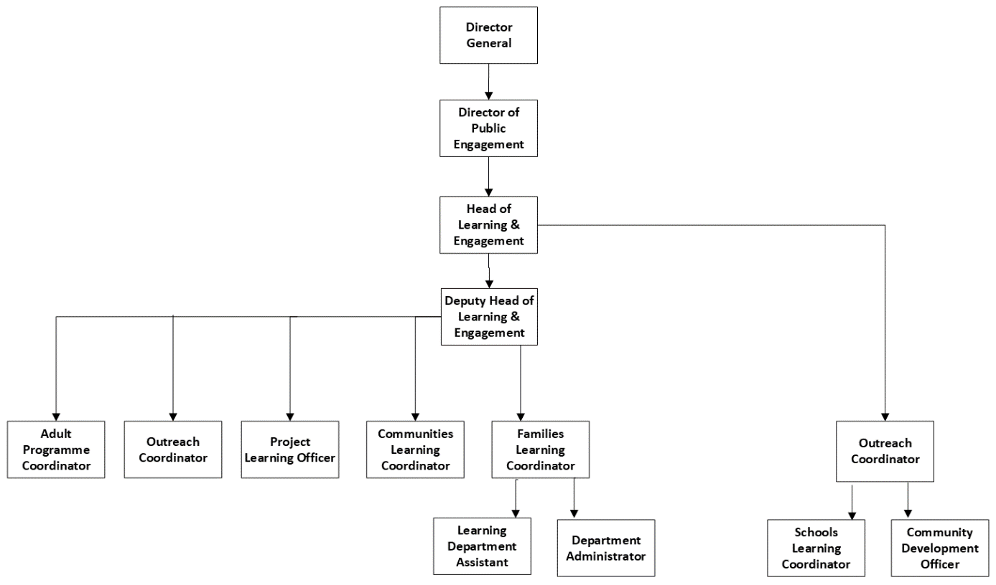

Responsibilities
- To develop, deliver and coordinate the new learning activities including virtual/online delivery within the Celebrating Scotland’s Art Activity Plan.

- Through the Activity Plan, work with target audience groups across Edinburgh and Scotland to gather information about their needs and collect responses to relevant artworks as part of the Interpretation Plan.

- To manage the relationship with and act as key contact for audience groups involved in the project, e.g. community groups, teachers and families, including audiences who do not currently visit.

- To liaise and work with Celebrating Scotland’s Art project-specific staff, volunteers and NGS colleagues, to help ensure the Activity Plan and Opening Project are delivered collaboratively and the activities and workstreams are integrated with NGS core programmes.

- To initiate and develop learning resources (including digital) and interpretation, in consultation with project staff and a range of audiences including schools, families and communities.

- To collect and report targets and measures for project evaluation and provide other reports as required.

- To plan and keep within budget and undertake administration relating to the post, including purchase orders, event forms, travel bookings.

- To represent and promote the work of Celebrating Scotland’s Art and the NGS to internal and external parties as required.

- Any other duties as reasonably required.

KNOWLEDGE, SKILLS AND EXPERIENCE

The following range of knowledge skills and experience are required. Please ensure these are reflected in your application. Short listing for interview will be based on meeting these requirements.

Essential
The post holder should have:

- Degree or equivalent level in an art-related subject, or equivalent knowledge, and demonstrable proof of on-going knowledge of a broad range of art.
- Experience of devising, coordinating and delivering new and creative learning programmes using art collections.
- Experience of working with a wide range of audiences, including schools, families, adults and community groups.
- Enthusiasm, creativity and a strong commitment to learning through a gallery or museum.
- Ability to demonstrate sensitivity and knowledge of the needs of underrepresented audiences. Knowledge and experience of creating digital content and learning resources for families, adults and schools.
- A team player with an active helpful manner, hands-on approach and flexible attitude to the duties of the post.
- Excellent interpersonal and communication skills (oral and written).
- Excellent IT skills.
- Meticulous attention to detail.
- Efficient time and work-schedule management and the ability to work on several tasks at any one time.
- Willingness to work flexible hours, including weekends, evenings, and holiday periods, as required.

Desirable:

- A broad-ranging and thorough knowledge of the NGS collection and in particular the collection of Scottish Art.
- Knowledge of and interest in Scottish history and culture.
- Experience of working on major capital museum or gallery projects funded by the National Lottery Heritage Fund.
- Knowledge of Gaelic and/or other European languages and an interest in Scots.

Applicants are asked to provide a written statement saying how their skills match the person specification and demonstrate the value and relevance of their experience to the post.

Selection Procedures: The applicants who meet the criteria based on the job description and the person specification and who demonstrate this in their written statement will be selected for interview.

SUMMARY TERMS AND CONDITIONS

Salary Band 6 £25,350 - £27,687

Starting salaries will normally be at the minimum or at a rate that reflects qualifications and/or experience which are of special value for the post and which are above minimum entry requirements.

Hours 42 hours per week inclusive of lunch breaks

Annual Leave 25 days per annum & 11.5 public and privilege holidays

Pension Civil Service pension provisions enables the National Galleries of Scotland to offer a choice of occupational and stakeholder pensions, giving you the flexibility to choose the pension that suits you best.

The closing date for completed applications is Sunday 20th February 2021

Please note that the successful candidate will be subject to PVG security clearance.

National Galleries of Scotland is a charity registered in Scotland (No. SC003728)

