NATIONAL GALLERIES OF SCOTLAND
THE ART WORKS PROJECT

COMMUNITY DEVELOPMENT OFFICER (BAND 5)
FIXED TERM PART TIME (22.5 hours per week) UNTIL END MARCH 2023

The National Galleries of Scotland (NGS) is home to one the world’s finest collections off art, which ranges from the Middle Ages to the present day. Our spectacular buildings house the world’s greatest collection of Scottish art, and a world-renowned collection of Scottish and international photography, welcoming many visitors to our three principal sites in Edinburgh: the Scottish National Gallery, the Scottish National Gallery of Modern Art and the Scottish National Portrait Gallery. The National Galleries of Scotland aims to preserve, display and augment the collections for the enjoyment and education of the widest possible public and to maintain NGS as a centre of excellence.

This is an exciting period of renewal for NGS, as we move forward with our engaging strategic vision that puts our audience at the heart of what we do. We’re making it our mission to broaden our impact, matching our rich collections, expertise and creativity to the needs and wants of our visitors. We’re finding new ways to connect with more people, and creating an innovative, inclusive organisation that can meet the challenges of our ever-evolving world.

‘Art for Scotland: Inspiration for the world’ is Our Vision. Inclusive, original and ambitious – we will make the national collection accessible to all and inspire curiosity across the world.

At NGS we are committed to looking at how we operate as well as how we engage with our visitors and communities. We want to play our part in tackling the Climate Emergency. We will ensure Equality, Diversity and Inclusion (EDI) is embedded across our organisation, ensuring everyone feels a sense of belonging and can be themselves.

The Art Works

The Art Works is our project to deliver a sustainable new facility for the National Galleries of Scotland to care for, research and share Scotland’s world-renowned collection of art. We will build a dynamic new facility in Granton, right at the heart of the local community, with spaces for local people and groups to meet and connect. It will be the largest building in Scotland designed to the Passivhaus environmental standard and, once open, it will operate at carbon net zero.

The Art Works will deliver world-class services for staff, researchers and visitors providing state of the art spaces for conservation and study as well as the management and distribution of Scotland’s art collection. This project is already allowing the National Galleries of Scotland and the local community to work together to create a positive and inspiring future for the area.

The Art Works offers a special opportunity deliver an inspiring place for looking and exploring, for talking and making, where visitors can experience the collection in a uniquely flexible way.

Department Structure:
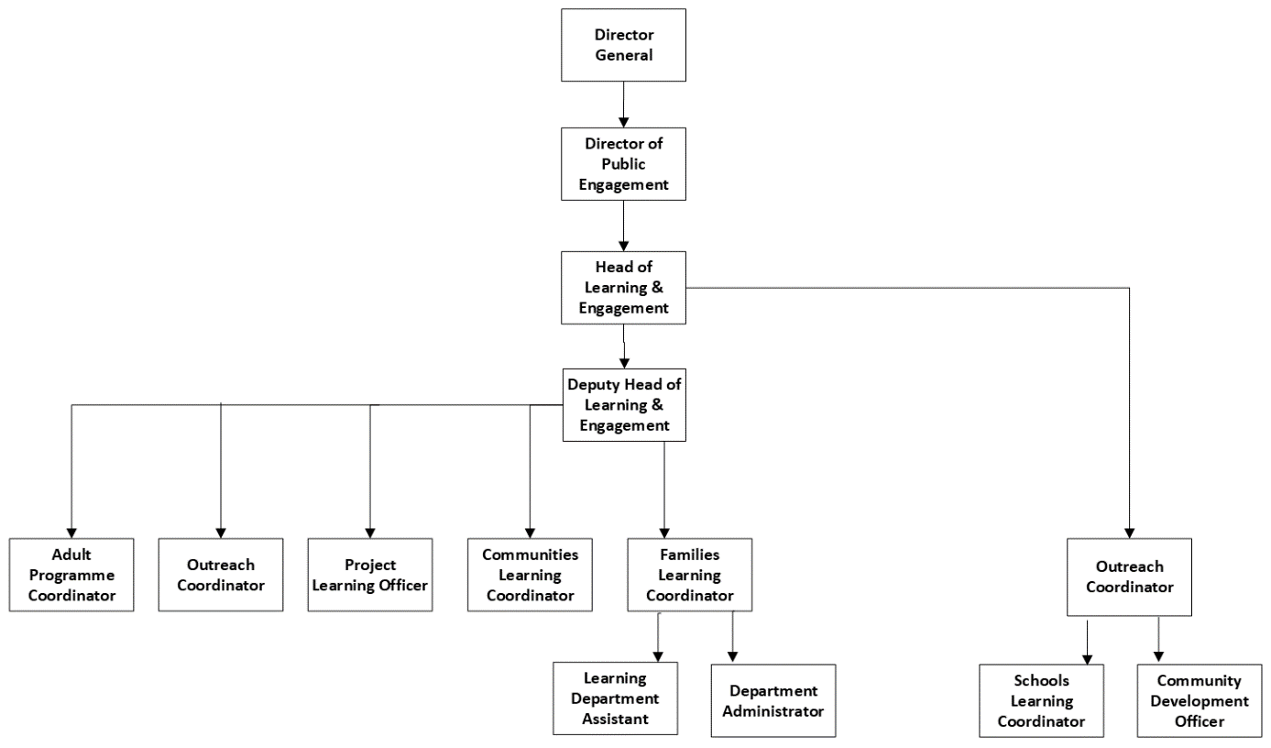

The Purpose and Scope of the Post

This role will ensure that NGS is responding to and working with the local community to embed The Art Works in North Edinburgh to enable it to make a positive contribution. The post holder will maintain and developing relationships with local groups and organisations. The role will enable the community voice to contribute and influence the Art Works in terms of its design and its contribution to the community. The role will be a conduit for clear and open communication between the local community, NGS colleagues and project partners. The research and insights gained through working with the community will support the wider NGS audience development planning and as such this post will have an awareness and understanding of the audience plans for NGS. The post will contribute to a community engagement plan for NGS and The Art Works.

MAIN DUTIES AND RESPONSIBILITIES

- Maintain, and develop new relevant, relationships with community groups and organisations in North Edinburgh
- Maintain up to date knowledge of community research, consultations, community planning for the local North Edinburgh area.
- Plan and deliver a financially viable programme of engagement for NGS and the local north Edinburgh communities that establish NGS presence in local area, and aligns with the strategic direction of The Art Works
- Integrate existing NGS programmes with local community
- Contribute to the development of The Art Works project through contributions to reports, team discussions, project decision making and collaborating across the project and NGS more widely
- Contribute to the development of a community engagement/integration plan for The Art Works pre and post opening

Knowledge, skills and experience

The following range of knowledge, skills and experience is required. Please ensure these are reflected in your application. Short-listing for interview will be based on meeting these requirements.

Essential:

- Understanding and knowledge of North Edinburgh area including Granton, Pilton, Royston/Wardieburn and the organisations and groups within that community
- Experience of working with and building relationships with a range of community representatives and partners
- Experience of creating, implementing and fully documenting community-based programmes
- Proven ability to work collaboratively within an organisation
- Excellent communication skills (both oral and written).
- Excellent IT skills
- Efficient time and work-schedule management.

Desirable

- Ability to think and work strategically
- Gaelic language skills

SUMMARY TERMS AND CONDITIONS

HOURS: 22.5 Hours per week excluding meal breaks

SALARY: £29,816 - £32,645 Pro rata

Starting salaries will normally be at the minimum or at a rate that reflects qualifications and/or experience which are of special value for the post and which are above minimum entry requirements

ANNUAL LEAVE: 25 days per annum pro-rata

Staff receive 10.5 public and privilege holidays per annum pro-rata

PENSION: Civil Service pension provisions enables the National Galleries of Scotland to offer a choice of pensions, giving you the flexibility to choose the pension that suits you best.

Closing date for applications Sunday 20th February 2022

Please note that the successful candidate will be subject to Basic Disclosure Scotland security clearance.

National Galleries of Scotland is a charity registered in Scotland (No. SC003728)

