**VISITOR ASSISTANT**

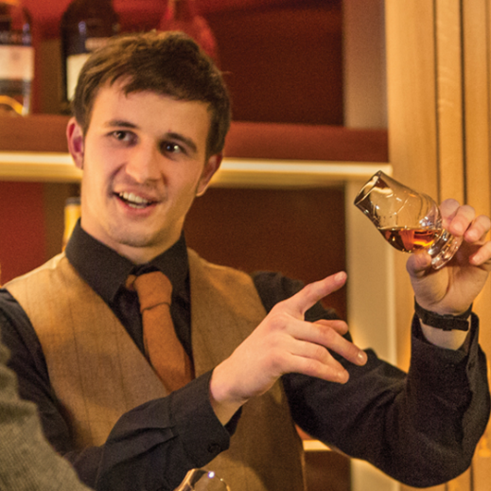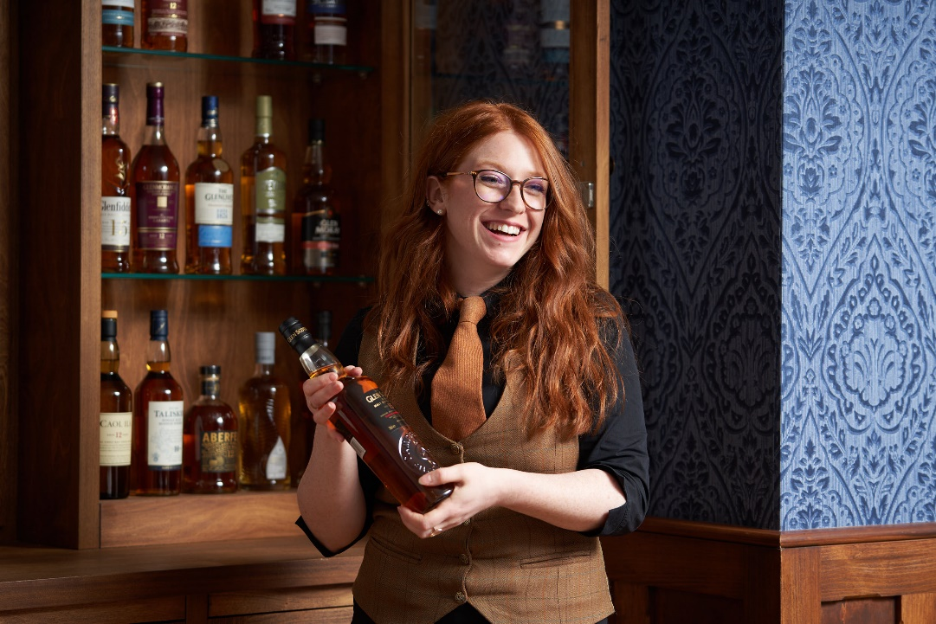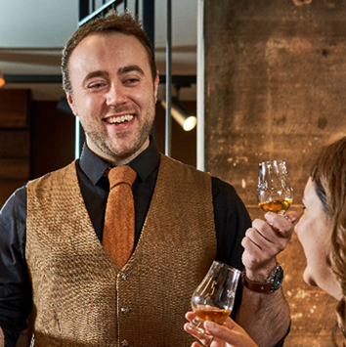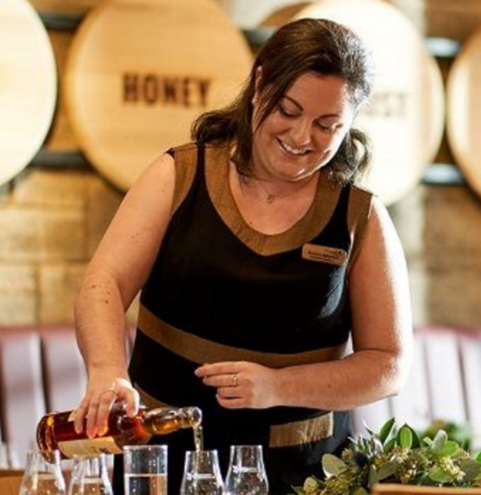

DYNAMIC STORYTELLER, PASSIONATE ABOUT CREATING MEMORIES

Proactively acknowledge every customer & deliver a warm, genuine welcome

Anticipate every customer’s needs so that no-one is disappointed

Connect each guest personally with Scotch whisky to make them feel valued

Uphold outstanding levels of service to overcome any problem or challenge

Ensure the customer experience you offer is never just fine, it is always excellent

What about you?

A confident, outgoing storyteller with a natural character

An engaging communicator overflowing with a warmth of spirit

An inquisitive, keen learner with a thirst for knowledge

A Scotch whisky ambassador bringing a blend of enthusiasm and devotion

A hardworking, flexible problem solver determined to raise the bar

A cheerful presenter always ready for a double measure of fun!

What will you be doing?

Proactively welcoming customers and proudly promoting our tours

Efficiently operating our box office till and offering advice to customers

Enthusiastically leading tours, ensuring everyone has a memorable experience

Assisting at our Scotch whisky bar and giving knowledgeable recommendations

General housekeeping to keep our bar, tour and shop looking their best!

Contract Full-time 36.25 hours per week

Hours rota based, includes evenings and weekends

Salary £11.45 per hour, increasing to 11.90 with experience

You will be busy; on your feet all day and you will be learning lots! Our friendly visitor assistants will look after you and encourage you to reach your full potential through regular training and coaching.

What about us?

We are a team of friendly and passionate storytellers in a five-star visitor attraction, and our vision is to make the world fall in love with Scotch whisky! Why not have a look around our website, or to get a better feel for our team’s enthusiasm, expertise and personality, why not read [our blog](https://blog.scotchwhiskyexperience.co.uk/)?

Our visitor assistant team work together to connect everyone- from absolute beginners to connoisseurs- with Scotch whisky.

Interested?

Do you think you’d bring something special to our team? Then we’d love to hear from you! Maybe you’ve worked in tourism before, or perhaps you speak a foreign language. If so, your [application](mailto:jobs@scotchwhiskyexperience.co.uk) will really stand out. But this isn’t essential; just tell us why you’d love to join our team.

We can’t wait to meet you!