**ACTIVITY CENTRE TEAM MEMBER**



Role Title: Activity Team Member

Contract Type: Full-time & Part-time

Start Date: ASAP

Salary: Negotiable depending on experience

Contact: Mark Harrison – mark@conifox.co.uk

**Conifox:**

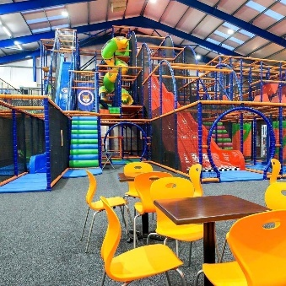Conifox is a family-owned business in Kirkliston. We operate a large fun-filled outdoor Adventure Park and a newly completed brilliant indoor Activity Centre. Our Adventure Park opened in 2015 and offers a great outdoor space for the whole family to enjoy, with crazy foot-golf, bounce pillow, sandpits, go-carting, picnic benches, BBQs, and a whole lot more.

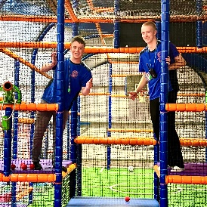The Activity Centre is huge and has a large fun-filled soft-play centre which includes a toddler area, a role-play toddler town, and a multi-level soft-play frame. The Activity Centre also incorporates 3 bright and beautiful birthday party rooms, a purpose built function suite, balcony, and a 400 seater café.

The Fetching Fox gastro pub offers a fantastic menu from producers all over Scotland.  From juicy steaks from Castle Game Scotland in Linlithgow to hand dived Orkney scallops you’ll die for. Perfect with some local beers and spirits and an array of jaw dropping cocktails with our own added foxy twist.

Throughout the year Conifox produces four large scale events: Easter, Fox Fest, Halloween, and Christmas with over 20,000 visitors expected at the 2022 Christmas Experience. Our events are designed for the whole family and offer a truly immersive experience.

**Role Summary:**

As a member of the Activity Team, you will have to have boundless amounts of energy in this customer facing role. Making sure all of our guests have a warm welcome and are well supervised whilst playing in any of our play areas and in the Adventure Park.

**Main Duties and Responsibilities:**

* Greeting every guest with a huge smile and striving to deliver outstanding customer service to all visitors in the Activity Centre and Adventure Park.
* Checking and selling admission tickets from the main reception desk.
* Setting up the equipment and ensuring it is safe for all of the children to play with.
* Assisting in cleaning all areas to maintain a high level of hygiene.
* Providing information to and interacting with customers.
* Monitor and control access to the Activity Centre and Adventure Park.
* Monitor play areas to ensure all children are playing safely and appropriately.
* Assist in the setup and take down of birthday party rooms.
* Being a birthday party host and making sure the birthday party is awesome.
* Reporting coded situations professionally and accurately.

**Qualifications and Experience:**

* 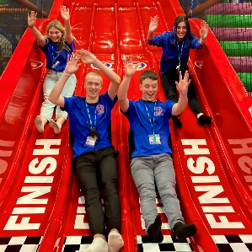Previous experience in delivering outstanding customer service in a public facing environment.
* Be fun & friendly, be able to work with others well and maintain a positive attitude at all times.
* Be hardworking, motivated, and be a great team player.
* Have excellent communication skills with both children and adults.
* Enjoy working and interacting with children.

**Staff Benefits:**

We’re growing fast and alongside a fun and friendly environment, we offer a fabulous package and amazing prospects.

* 28 days annual leave (Pro-rata)
* Flexible working hours
* Discount children’s parties
* Free access to events
* Discounted family tickets

If you think this is a challenge you’d like to accept or find out more about then email us and we can give you more reasons to be part of the Conifox Family.