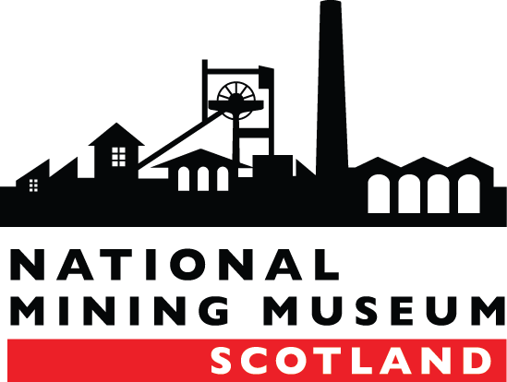
NATIONAL MINING MUSEUM SCOTLAND
JOB DESCRIPTION
Post Title: | Café Assistant
Salary: | £10:90 per hour
Contract: | Temporary and part-time
Reports to: | Marketing and Events Manager / Visitor Services Officer

TO APPLY
Please complete the Application Form and Equalities Form and email this to reception@nationalminingmuseum.com by Tuesday 8th August at 5pm.
Please note CVs are not accepted as part of the application process.

BACKGROUND

The National Mining Museum Scotland is an independent trust and the national body responsible for the preservation and interpretation of Scotland’s Mining Heritage. The museum holds a collection of objects of national significance and is on the site of the Lady Victoria Colliery, built in the 19th Century, in Newtongrange, Midlothian.
The museum offers a wide range of activities and events to a diverse audience of local, national and international audiences. The visitor experience includes access to the collections through tours and exhibitions, an award winning education programme and an inviting shop and café area.

PURPOSE OF POST
To assist in the café of the National Mining Museum Scotland, which will include; preparation of and serving food, creating menus, assisting with orders and stocktake. The post holder will be part of the front of house team and the role will be customer facing, which will require a high standard of customer service and engagement.

KEY RESPONSIBILITIES

- Act as a front of house server for the café and in-house functions; includes preparing hot drinks and serving food.
- Be customer focused at all times; approachable and quick to exceed expectations in fulfilling customer needs.
- Ensure that customers receive a prompt and efficient service and expectations are met.
- Ensure that food storage areas are maintained in accordance with the museum’s Food Safety Management System, Healthy and Safety and Environmental policies and procedures.
- Adhere to the museum’s Food Hygiene, Health and Safety and Environmental policies.
- Adhere to cash handling and the museum’s financial regulations.
- Assist in the preparation and cooking of menu items as set out in the daily menu.
- Assist with café stock taking when required.
- Ensure stock, deliveries and wastage are all checked and recorded in line with company and food standards.
- Assist with food orders.
- Cleaning duties including keeping café, serveries and kitchen clean and tidy at all times, in accordance with required standards.
- Be a team player, assisting other team members when necessary.
- Flexible working required and ability to work weekends.
- Be aware of locking up and security procedures on site and other regulatory policies such as health and safety and fire regulations.
- Be available for training updates on food hygiene standards and similar areas when required.
PERSON SPECIFICATION
 | Essential | Desirable | Measured by
Qualifications
Food Hygiene certificate. |  | x | Certificate to be produced at Interview
Experience
Experience in museum/visitor attraction or similar environment. |  | x | Application form; interview questions;
Experience in a café or similar hospitality environment | x |  | Application form; interview questions;
Awareness of food hygiene regulation. | x |  | Application form; interview questions;
Experience of working with the public | x |  | Application form; interview questions;
Experience of good customer services | x |  | Application form; interview questions;
Skills and Attributes
Good customer engagement skills. | x |  | Application form; interview questions; probation period
Good communication skills, interpersonal, written and verbal. | x |  | Application form/ interview questions
Understanding of ICT technology and using a cash till. | x |  | interview questions; probation period
Awareness of cash handling and documentation. | x |  | interview questions; probation period
Ability to be part of the museum’s front of house team and to help drive forward the museum’s strategic plan. | x |  | interview questions; probation period
Ability to be a good team leader and to manage staff and volunteers. | x |  | Application form/ interview questions
Other
Driving Licence. |  | x | To be produced at Interview
Flexible, able to work evenings, weekends and public holidays. | x |  | Interview questions; probation period
Be approachable and have a friendly disposition. | x |  | Interview questions; probation period
Ability to work in a busy customer-facing environment. | x |  | Interview questions; probation period
Attend regulatory and customer facing training as required. | x |  | Interview questions; probation period

