|  |  |  |
| --- | --- | --- |
|  | Job Description | January 2024 |

|  |  |
| --- | --- |
| **Role:** Visitor Services Manager | **Region / Department:** Edinburgh & East |
| **Reports to:** Operations Manager | Pay Band: Grade 4 lower £30,239 - £33,279 pro-rata, per annum |
| **Location:** Falkland Palace | **Type of Contract:** Permanent / full time, 40 Hours per week |
| **COST CENTRE**: 3FAP | **ACTIVITY CODE**: PMZ |
| **Note**  *The post is subject to the standard terms and conditions provided with the application pack. It will include regular weekend and some evening working.* | |

# JOB PURPOSE

You will be responsible for the operation of Falkland Palace. Delivering performance standards and targets to ensure enjoyment of the property by visitors and members is maximised and key commercial, financial and development objectives are achieved to make the property fully sustainable.

You will lead a management team responsible for delivering an overall visitor service strategy, care of the site, including retail, events and admissions and liaise with colleagues responsible for collections care, estates management and gardens. Promoting good communication across the site and a joined up service provision.

# KEY RESPONSIBILITIES AND ACCOUNTABILITIES

You will lead a team to support the overall experience at Falkland Palace – currently including visitor experience, events, admissions and retail.

* Staff and volunteers - (recruitment, induction, development, motivation, performance management) such that they are fully equipped and motivated to undertake their duties to the required Trust standards and that staffing budgets are adhered to.
* Instil a Health & Safety culture across the property, ensuring the team work within the property’s ‘Safe System of Work’ to reduce risk of incidents and accidents to volunteers, employees and visitors.
* Budgets - (setting, phasing, monitoring, reporting, pro-active and re-active adjustments together with the Operations Manager and wider management teams) to ensure that the finances are sustainable within the context of the wider property budgets.
* Create a culture of ‘exceptional service, every time’. Delivering high standards of delivery and a consistently warm welcome within the visitor experiences at all properties.
* Driving the visitor services experience to achieve its financial targets, maximising income and profitability, using the Trust’s procedures and instructions. You will strive to be efficient and ensure cost effectiveness in all the work you do.
* You will ensure high standards of presentation across the property, you may have delegated tasks within other departments and you will understand and help deliver your overall property business plan.
* Work closely with other VSMs and Head Gardeners in the Fife cluster to develop visitor strategies for all sites.
* Taking responsibility for opening and closing and security of buildings as well as emergency procedure implementation, duty management and providing relief cover as required.
* Designing and developing tours, events and visitor experiences that engage visitors through storytelling.
* Establishing visitor experiences which are relevant, socially inclusive engaging to all visitor groups.
* Ensuring that all formal and informal learning experiences are designed and developed in line with the curriculum for excellence and the target audience needs
* Managing the promotion and administration of visitor experience and events together with property VSS’s
* Ensuring that the longevity of the Trust’s buildings and fittings are maximised through appropriate maintenance and/or replacement regimes.
* To ensure that the property meets statutory and company requirements of Health and Safety, Food Safety and Environmental legislations and procedures including Waste Disposal and Allergens.
* Adhering to the sale of alcohol legislation, being a Premises Manager.

# REQUIRED QUALIFICATIONS, SKILLS, EXPERIENCE & KNOWLEDGE

**Qualifications**

Essential

* NVQ3/BTEC/City & Guilds/HND/Degree or equivalent experience.
* Ability to work ‘hands-on’ – including in the kitchen/retail and admissions areas – alongside the team members, demonstrating the customer service skills required of all staff.
* Hold a valid and recognised SQA Licensing Qualification e.g. Scottish Personal License Holder's Certificate and Personal License.
* Current driving licence.

Desired

* IOSHH managing safely.

**This role is one for which the duties, responsibilities or accountabilities of the role require you to undertake a criminal records check, specifically a Basic Disclosure.**

**Skills, Experience & Knowledge**

Essential

* Have direct experience of managing multi-strand visitor/commercial services in a hospitality, heritage or tourist-attraction context.
* Possess excellent communication skills (written and oral).
* Computer literacy with excellent ability on MS software.
* Excellent leadership and influencing skills.
* Excellent understanding of report writing and financial management.
* Well developed time management and organisation skills.
* Experience in using social media to promote events.

Desirable

* Management of volunteers
* Current First Aid certification (or willingness to train and use)

**DIMENSIONS AND SCOPE OF JOB**

People Management

* Direct line management of all staff and responsible for volunteering on site.
* Provision of full facilities welcoming about 50,000 visitors per annum. To include clean and safe visitor facilities, retail, excellent customer care, First Aid cover, ticketing and recruitment.
* Working closely with specialist Trust staff (e.g. in finance, commercial, buildings maintenance, conservation, marketing, health & safety, human resources, learning services) based at central support or other bases to ensure Trust policies and standards are implemented.
* Will work occasionally with other property colleagues and will have some interaction with other technical/specialist advisory colleagues based in other locations and departments.
* Will have regular (daily) interaction with members of the public of all ages and abilities.
* Will have frequent interaction with suppliers and contractors, including procurement and appropriate selection according to Trust requirements (e.g. insurance levels).
* Developing and maintaining sound relationships with local stakeholders.
* Occasional leading and participating in multi-disciplinary project teams consisting of in-house staff and external consultants/contractors.
* Attending meetings, training and updates such as the Cluster Lead meetings, budget meetings and keep professionally informed.

Finance Management

* Work within an approved budget for approximately £400k income and £550k expenditure annually.
* Will be a frequent user of the Trust’s computerised purchasing and weekly reporting systems.
* May be a Project Manager, adhering to the Trust’s Project Management processes.
* Weekly banking and adherence to the Trust’s Cash Handling Procedures.

**Place in organisational structure:**

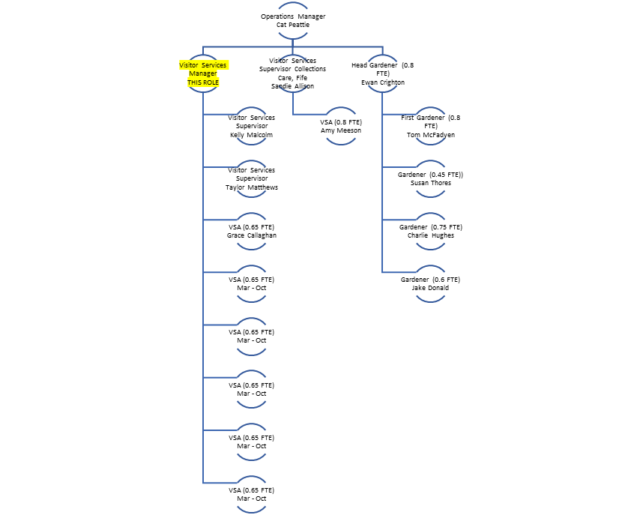

# The Key Responsibilities, Scope of Job, and Required Qualifications, Skills, Experience & Knowledge reflect the requirements of the job at the time of issue. The Trust reserves the right to amend these with appropriate consultation and/or request the post-holder to undertake any activities that it believes to be reasonable within the broad scope of the job or his/her general abilities.

**Applications**

Interested applicants should forward their Curriculum Vitae (CV) or an Application Form to the People Services Department (Applications) by email via workforus@nts.org.uk, by Sunday 4th February 2024

Please ensure your CV includes your full name and contact details, the CV file sent to us should be titled your first initial and surname. When submitting your CV please state the position and job location of the vacancy you are applying for in the subject title or body of your email: For example "Gardener - Culzean"