|  |  |  |
| --- | --- | --- |
| Description: Description: cid:_com_android_email_attachmentprovider_1_4837_RAW@sec.galaxytab | Job Description | January 2024 |

|  |  |
| --- | --- |
| **Role:** Visitor Services Supervisor | **Region:** Edinburgh & East |
| **Reports to:** Operations Manager (Borders) | Pay Band: Grade 3 Lower, £25,603 - £27,318 pro-rata, per annum |
| **Location:** Priorwood Garden, Abbey Street, Melrose, TD6 9PX | **Type of Contract:** Permanent, full-time, 40 hours *variable work pattern**including regular weekend work* |
| **COST CENTRE :** 3PRI | **ACTIVITY CODE:** VSZ |

# JOB PURPOSE

To provide operational coordination and supervision of Priorwood and Harmony garden visitor services, events, tenant relationships and holiday lets in line with the Trust’s policies, priorities, performance standards and targets to contribute to the enjoyment of the property by visitors and members, and help ensure commercial, financial, and conservation objectives are achieved.

The Visitor Services Supervisor at a Trust property plays a pivotal role ensuring that the management objectives are achieved through excellent customer service, and, with delegated responsibility for events and duty management they are very often the “face” of the Trust to visitors and suppliers. As such, they directly influence public perceptions of the Trust and is crucial to developing and maintaining the property’s local/national reputation.

You will be part of a broader management team responsible for delivering an overall visitor service strategy, promoting good communication across the sites and a joined-up service provision.

# KEY RESPONSIBILITIES AND ACCOUNTABILITIES

* Supervising/undertaking the day-to-day operation of the visitor services and guest services function. This includes:
  + Working with the garden team to develop produce sales and an events programme.
  + Housekeeping and security of the Property.
  + Health and safety procedures, emergency procedures, and environmental procedures.
  + Looking after the holiday let bookings and guests.
* Typically working Tuesday to Saturday and 9am to 5pm (most holiday let arrivals are on Fridays and Saturdays), however flexibility around days to fit the business needs are required.
* Required to be on call for any Holiday Let emergency situations.
* Create a culture of ‘exceptional service, every time. Delivering high standards of performance and a consistently warm welcome to all users of the properties.
* Responsible for day-to-day financial administration at the property, including cash/till reconciliation, completion of the banking processes, and support reporting of working hours for payroll.
* Collation of visitor numbers.
* Supporting the Operations Manager with the recruitment; induction; development; and management of volunteers such that they understand and are equipped to fulfil their roles to the standards required and that they feel valued, respected and supported.
* Instil a Health & Safety culture across the property, ensuring the teamwork to reduce risk of incidents and accidents to volunteers, employees and visitors. This includes developing and maintaining risk assessments.
* Take responsibility for opening and closing and security of buildings as well as emergency procedure implementation, duty management and providing relief cover as required.
* Keep on top of holiday let and residential property compliance and maintenance.
* Responsible for local community engagement, growing relationships and co-ordinating mutually beneficial events.
* Actively recruiting members and promoting relevant fundraising campaigns.
* Work with Trust specialists to promote the properties to Travel Trade operators and host visits.
* Supporting the Operations Manager in driving the visitor services experience at the properties to achieve its financial targets, maximising income and profitability, using the Trust’s procedures and instructions. Ensuring efficiency and cost effectiveness in all aspects of work.
* Develop local level stakeholder and client relationships including the Borders Book Festival Trust and local tenants.
* Ensure that lifelong learning is developed and promoted at the Properties through the visitor experience.
* Develop and promote the property through local, regional and national marketing initiatives and through social media.
* Attendance at regional and national meetings when required (held in various locations across the country).

*This role is one for which the duties, responsibilities or accountabilities of the role require you to become a member of the Protection of Vulnerable Groups (PVG) scheme, administered by Disclosure Scotland, as this role involves regulated work with children.*

# REQUIRED QUALIFICATIONS, SKILLS, EXPERIENCE & KNOWLEDGE

**Qualifications**

* No formal educational qualification required (but see “Experience” below);
* A full, clean driving license for driving in the UK.
* Current First Aid certification (or willingness to train and use).

**Skills, Experience & Knowledge**

Essential

* Significant previous experience of working in an operations role in the catering/visitor/heritage attraction industry – including supervision of volunteers and/or responsibility for specific activities.
* Previous event coordination/management experience.
* Strong personal belief in the value of excellent customer care with the ability to translate this into actions.
* Excellent organisational, administrative, and time-management skills with the ability to prioritise and re-prioritise workload to meet changing demands.
* Proven sales skills with the ability to achieve targets.
* The ability to think and act quickly when confronted with emergencies.
* Competent user of Microsoft Office products.
* An understanding and commitment to the aims and objectives of the National Trust for Scotland.
* Living the values of the National Trust for Scotland and encourage colleagues to do the same:
  + The ability and willingness to understand others’ perspectives and to consider the impact of your actions on them and to adapt your actions as necessary.
  + The ability and willingness to learn and try new things, to be flexible and step outside of your comfort zone.
  + An open and honest way of communicating, ready to ask others for their ideas and to be open to hear and consider different points of view.
  + A pro-active approach to taking initiative and to driving forward ideas and projects designed to improve daily operations and deliver an exceptional visitor experience.

Desirable

* Experience of using social media in a workplace context.
* Experience managing holiday lets and tenant relationships.

**DIMENSIONS AND SCOPE OF JOB**

Scale

* The National Trust presence in Melrose contains Harmony and Priorwood Gardens, three holiday lets, a residential tenancy and several commercially let spaces.
* Public and private events held in Harmony Garden, Harmony Orchard and Priorwood Garden.
* Presentation and condition standards of Melrose Holiday Lets (Harmony House, Harmony Cottage & Pear Cottage).
* Utilising the properties for workshop events and enhancing community engagement.

People Management

* At present there are no line reports, but this may be subject to change.
* Welcoming and provision of facilities for property visitors and events visitors.
* Working closely with specialist Trust staff based at local and central support bases to ensure Trust policies and standards are implemented.
* Positively engaging with all visitors and the local community to maintain and grow relationships.
* Grow the pool of active volunteers across all areas of the property.
* Professional relationships to be built with the Holiday Let Cleaners and all contractors (e.g., annual compliance requirements).

Financial Management

* Not a budget holder, but will be asked to manage spend within defined limits.
* Will be required to use Trust systems for the purpose of raising PO’s.
* Cash handling and reconciliation of till.
* Banking procedures.
* Processing of membership enrolments.
* Timely completion of property payroll timesheets in absence of head gardener.

Tools / equipment / systems

* Use PC/Laptop for access to NTS intranet, all relevant NTS on-line systems and third party sites (e.g. Eventbrite).
* Introduction of new EPOS system on site.
* Mobile phone for Holiday Cottage guest emergency contact.

**Organisational structure chart showing role:**

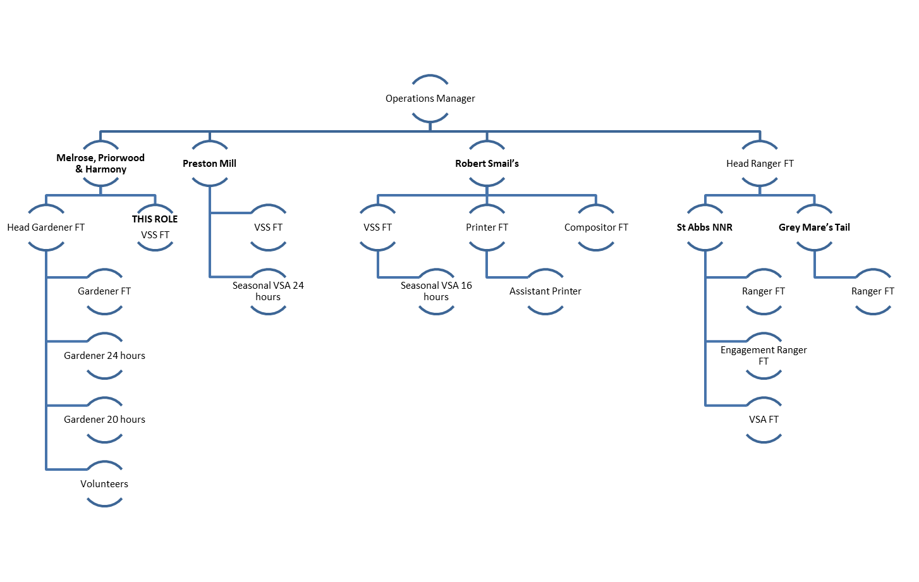

# The Purpose, Context, Key Responsibilities, and Person Specification reflect the requirements of the job at the time of issue. The Trust reserves the right to amend these with appropriate consultation and/or request the post-holder to undertake any activities that it believes to be reasonable within the broad scope of the job or his/her general abilities.

**Applications**

Interested applicants should forward their Curriculum Vitae (CV) or an Application Form to the People Services Department (Applications) by email via workforus@nts.org.uk, by Sunday 4th February 2024

Please ensure your CV includes your full name and contact details, the CV file sent to us should be titled your first initial and surname. When submitting your CV please state the position and job location of the vacancy you are applying for in the subject title or body of your email: For example "Gardener - Culzean"