 | Job Description | January 2024

Role: Seasonal Ranger | Region / Department: Highlands & Islands
Reports to: Property Manager (Inner Hebrides) | Pay Band: Band 3 Lower, £25,603 - £27,318 pro-rata, per annum
Location: Island of Staffa, Argyll | Type of Contract: Full time (40hr/week),  Fixed-term Contract, March-End of August  (may include weekend and evening working)
COST CENTRE (e.g.: 3CUZ): 3TRE | ACTIVITY CODE (e.g.: VSZ): RAZ

JOB PURPOSE

The Seasonal Rangers will be the face of the National Trust for Scotland in Staffa during the busy summer months. The Seasonal Ranger will welcome visitors and help ensure their time on Staffa is highly enjoyable and memorable, while at the same time helping to protect and enhance the island’s natural and cultural heritage. They will play a critical role in forging a strong and close working relationship with Day Boat Operators.

KEY RESPONSIBILITIES AND ACCOUNTABILITIES

Visitor Services
- Welcoming and engaging visitors, enhancing their experience by providing information about Staffa and the Treshnish Islands, the geological, natural, built and cultural heritage, including strong messages around safety and respect for wildlife.
- Encourage people to further contribute to caring for Staffa through donating or taking up membership of NTS.
- Collect donations made on the island and securely transfer them to the full-time Ranger or Property Manager for receipting and banking.
- Assist with practical countryside management including safety checks of visitor infrastructure, litter picks, beach cleans and maintenance.
- Lead and assist with events such as guided walks and talks as appropriate.

Nature conservation
- Contribute to National Trust for Scotland biological monitoring programmes including seabird surveys and regular biosecurity checks.
- Manage and collate biological information in a consistent manner compatible with Trust and national datasets.

Community engagement
- Build strong working relationships with Day Boat Operators, their crew members, and other local stakeholders to support consistent messaging to visitors.

Marketing & Communications
- Enthusiastically promote awareness and understanding of the role that NTS plays in protecting and caring for Staffa, Lunga, the Treshnish islands and wider work across Scotland.
- Regularly update and contribute positive stories to NTS social media and other communication outlets relevant to Staffa and Lunga.

Learning
- Assist the Ranger Team with educational and other outreach activities on site or to the local community and to communities of interest, including volunteers.
- Collaborate on projects with the National Trust for Scotland’s experts.

Other responsibilities
- Ensure that all activities undertaken are compliant with the Trust’s health and safety policies and procedures including the Safe System of Work, Visitor Safety in the Countryside, and environmental policy and practices, mindful of impacts on people and environment.
- Contribute knowledge and experience to projects and management decisions within the NTS Plan for Nature.
- Provide occasional support to Mull & Iona Ranger Service with projects and activities across the southwest of Mull, Staffa, Burg or Iona.
- Criminal records (Disclosure Scotland) checking and clearance essential for safeguarding of children/vulnerable adults. The role is one for which the duties/responsibilities/accountabilities of the role will require staff to become a member of the Protection of Vulnerable Groups (PVG) scheme.

REQUIRED QUALIFICATIONS, SKILLS, EXPERIENCE & KNOWLEDGE

Qualifications

Essential
- Graduate level qualifications or equivalent experience in one or more of the following subject areas: heritage or cultural studies, visitor services, rural land management, nature conservation, environmental studies.

Experience

Essential
- Excellent communication skills and the ability to interact positively with a wide range of people in person and through other written or visual forms.
- Ability to implement work in a lone working and challenging environment and communicate well within a small team.
- Willingness to initiate conversational relationships with visitors and community partners, be approachable and welcoming.
- Excellent organisational, time-management skills with the ability to prioritise and be flexible according to weather and changing demands.
- Ability to gather and record data consistently.
- Competent user of Microsoft Office and social media.
- A sound knowledge of issues affecting the conservation and management of Scotland’s environment (landscapes, habitats, and wildlife).
- Proven track record of delivering visitor experience within a countryside context.
- Experience of managing safety in the countryside.
- An understanding and commitment to the aims and objectives of the National Trust for Scotland.
- Living the values of the National Trust for Scotland and encouraging colleagues to do the same.

Desirable
- Knowledge of and interest in the cultural and natural history of the Hebrides.
- Working knowledge of ecological survey and monitoring techniques.
- Practical land management and maintenance of small-scale rural estates infrastructure.
- Ability to think and act quickly when confronted with emergencies.
- Up to date First Aid certificate.

DIMENSIONS AND SCOPE OF JOB

Scale
- The post holder, alongside two other Seasonal Rangers, will be the main NTS presence and point of contact on Lunga and Staffa. They will work within a small team comprising the Property Manager; the full-time Ranger; three Seasonal Rangers and the Visitor Services Assistant (Iona Shelter Caretaker) as well as a number of volunteers.

People Management
- No line management responsibility, but will be required to supervise volunteers on occasion.
- Develop and maintain positive relationships with Day Boat Operators, visitors, NTS staff (local team and other technical/specialist advisory colleagues), contractors, residents and businesses in around the SW Mull and Iona area.
- Will have regular interaction with members of the public of all ages and abilities. Staffa attracts around 100,000 visitors each season.

Finance Management
- Collection of cash and with full-time Ranger or Property Manager accurately account for weekly amounts within Trust Cash Handling Guidelines and Policies.
- Assist in making the best use of resources and ensuring best value.
- Contribute to the income of the Trust through recruiting new members and encouraging donations.
- This role is not a budget-holder.

Travel and Wellbeing
- Travel to Staffa will be provided by local boat operators.
- NTS will provide branded outerwear and footwear appropriate for the Staffa environment.
- NTS will provide a tented shelter on Staffa for use in inclement weather and for the storage of equipment, clothing and other appropriate materials.
- The ranger will be supplied with a Spot Locator to enhance safety that will be enabled at all times when delivering the above Service.

Place in organisational structure:

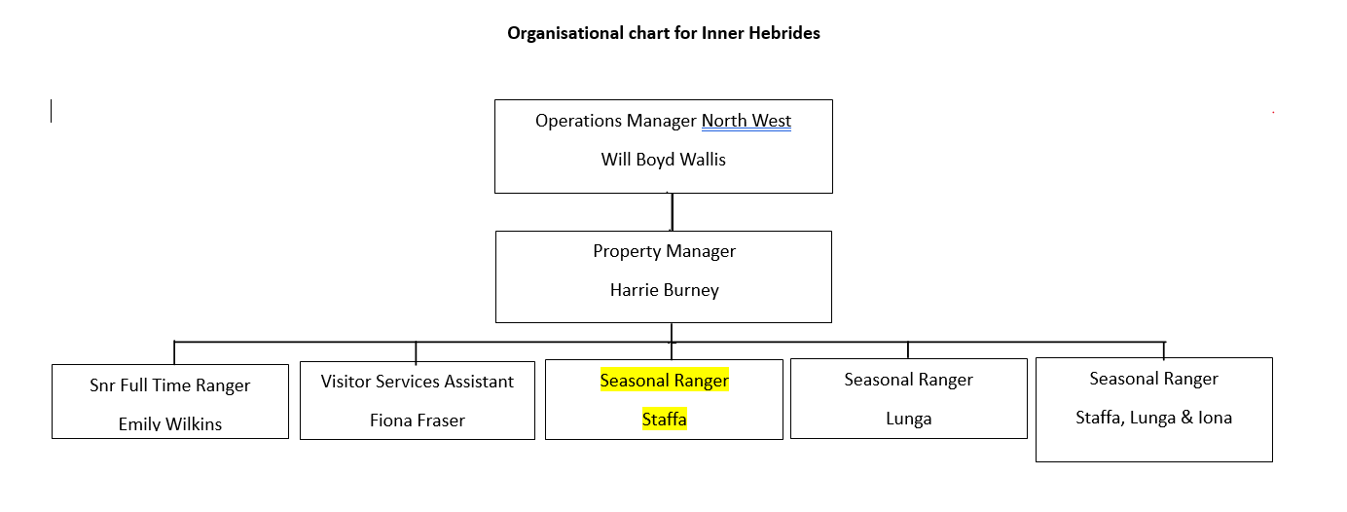

The Purpose, Context, Key Responsibilities, and Person Specification reflect the requirements of the job at the time of issue. The Trust reserves the right to amend these with appropriate consultation and/or request the post-holder to undertake any activities that it believes to be reasonable within the broad scope of the job or his/her general abilities.

Applications
Interested applicants should forward their Curriculum Vitae (CV) or an Application Form to the People Services Department (Applications) by email via workforus@nts.org.uk, by Sunday 11th February 2024
Please ensure your CV includes your full name and contact details, the CV file sent to us should be titled your first initial and surname. When submitting your CV please state the position and job location of the vacancy you are applying for in the subject title or body of your email: For example "Gardener - Culzean"

