|  |  |  |
| --- | --- | --- |
| Description: Description: cid:_com_android_email_attachmentprovider_1_4837_RAW@sec.galaxytab | **Job Description** | 2024 |

|  |  |
| --- | --- |
| **Role:** Visitor Services Assistant | **Region / Department:** Edinburgh & East |
| **Reports to:** Visitor Services Supervisor | Pay Band: Grade 2 Lower, £10.90 per hour, £22,672 pro-rata, per annum |
| **Location:** Preston Mill & Phantassie Doocot | **Type of Contract:** Seasonal, part-time 24 hours per week (1st April to 31st October) |
| **Cost Centre:** 3PRM | **Activity Code:** VSZ |
| **Terms and Conditions:** The post is subject to the standard terms and conditions provided with the application pack and the following special terms also apply: hours of work over a 5 day period (Thursday to Monday) and at times to suit the needs of the job (this may include regular weekend shifts/duties). | |

# JOB PURPOSE

To maximise our visitors’ enjoyment of Preston Mill & Phantassie Doocot by maintaining excellent standards of service, optimising opportunities to generate income and ensuring that the site and its assets are safe and secure.

Specifically, to ensure the smooth and safe operations in Admissions, Tours, Retail, Catering and Events activities making the property the best possible place to visit and work.

# KEY RESPONSIBILITIES AND ACCOUNTABILITIES

**To provide a consistently high standard of visitor care at all times**

* Welcoming all visitors to the site and processing their bookings, admissions, retail or catering purchase in a friendly, efficient and knowledgeable manner.
* Welcoming visitors with special needs / impairments and providing a high level of service in accordance with the Disability Discrimination Act.
* Welcoming International visitors and groups, aiding with specific needs in a warm and efficient manner.
* Stock-rotation and merchandising to promote and maximize sales in the shop.
* Answering visitors’ queries about the site, education facilities and the local area.
* Providing information about the site, its history, contents, offers and merchandise.
* Promoting National Trust for Scotland brand to include our Membership scheme, events, upselling other properties and any promotional campaigns, being proactive in the selling of Membership and Gift Aid.

**To maintain excellent standards of site and personal presentation at all times**

* The general ongoing operational cleaning of all areas as necessary, toilet cleaning, emptying waste bins and as appropriate vacuum cleaning, mopping, sweeping, dusting and polishing when required.
* Ensuring site is ready to open and welcome visitors by the set opening time.
* Wearing correct uniform, name badges, or PPE as required, keeping up to date with compliance.
* Reporting all instances of damage and wear and tear issues promptly to your line manager.
* Working in harmony with other departments; housekeeping, gardening, grounds maintenance and site repair employees/contractors and representing the values of the National Trust for Scotland.

**Retail/Catering/Events/Cashier duties (where applicable)**

* To ensure good housekeeping of catering kitchens, serveries and back of house areas.
* To ensure that retail merchandising is in accordance with NTS policy.
* To assist in achieving site retail/catering/events targets and KPI’s.
* To actively upsell products and services to facilitate the visitor’s enjoyment.
* To actively feedback visitor comments to line managers to develop and improve offer, service, operations.
* To work flexibly across departments and sites as needed.
* To assist with the set-up, stewarding and break-down of events in liaison with the events coordinator.
* To assist with Heritage Hospitality events. Staff may be asked to work through into the night hours.

**Health and Safety**

* To ensure site meets with Health and Safety legislation in liaison with your department manager.
* To ensure that visitors vacate the site at close of business and that the site is secured at end of day.
* To use personal protection equipment as provided and directed by your line manager.

# REQUIRED QUALIFICATIONS, SKILLS, EXPERIENCE & KNOWLEDGE

**Qualifications**

* No formal educational qualification required.

**Skills, Experience & Knowledge**

Essential

* Demonstrable experience in a customer-facing retail-based role, delivering impeccable customer care through excellent inter-personal skills.
* Demonstrable experience in a catering-based role, delivering impeccable customer care and food safety standards.
* Demonstrable experience in sales or ticket/event/admissions – ideally in a heritage/tourism context - with experience and confidence undertaking till-work and cash handling/reconciliation.
* Experience in non-EPOS style till operation.
* Excellent cash handling skills.
* Excellent “front of house” persona – warm, welcoming, patient, understanding.
* Excellent selling skills – adaptable to customer type and product.
* Demonstrable excellent time management skills and the ability to prioritise.
* Flexible, helpful outlook to customers and colleagues.
* An understanding and commitment to the aims and objectives of the National Trust for Scotland.
* Living the values of the National Trust for Scotland and encourage colleagues to do the same.
  + The ability and willingness to understand others’ perspectives and to consider the impact of your actions on them and to adapt your actions as necessary.
  + The ability and willingness to learn and try new things, to be flexible and step outside of your comfort zone.
  + An open and honest way of communicating, ready to ask others for their ideas and to be open to hear and consider different points of view.
  + A pro-active approach to taking initiative and to driving forward ideas and projects designed to improve daily operations and deliver an exceptional visitor experience.

Desirable

* Experience in storytelling and a passion for Scottish heritage and history
* Experience of using social media in a workplace context.

**DIMENSIONS AND SCOPE OF JOB**

Scale

* Support the property VSS in property presentation, retail sales and tour delivery.
* Occasionally take charge of the property on days of VSS absence (holiday/meetings etc).
* Supporting public and private events held in buildings and surrounding land.

People Management

* At present there are no line reports, however, must work collaboratively with volunteers.
* Welcoming and provision of facilities for property visitors and events visitors.
* Positively engaging with all visitors and the local community to maintain and grow relationships.

Financial Management

* Not a budget holder but will be asked to work within defined limits.
* Cash handling and reconciliation of till.

Tools / equipment / systems

* Use PC/Laptop for access to NTS intranet, all relevant NTS on-line systems and third-party sites (e.g. Eventbrite).
* Support smooth introduction of new EPOS system on site.

**Organisational structure chart showing role:**

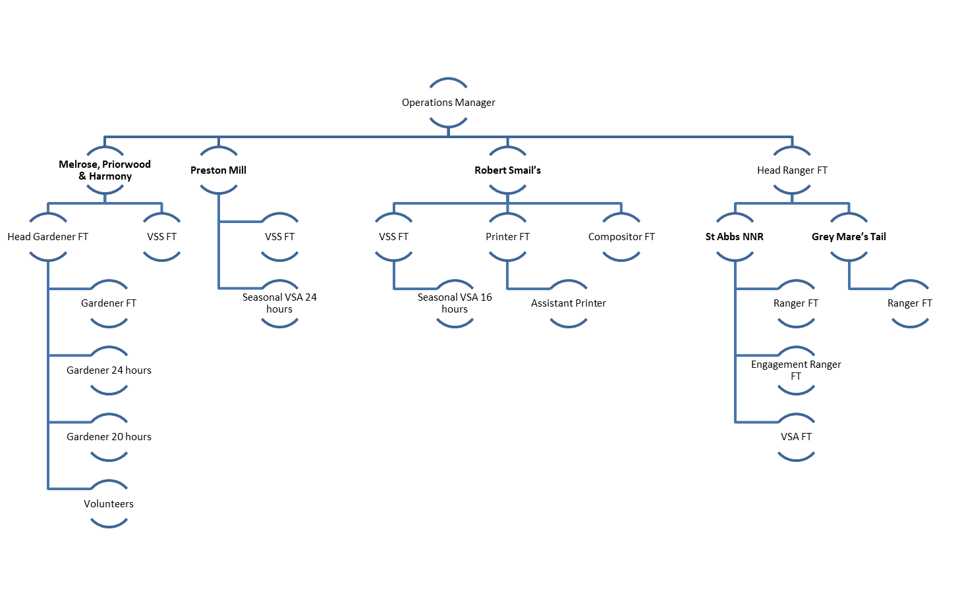

**The Key Responsibilities, Scope of Job, and Required Skills, Experience & Knowledge reflect the requirements of the job at the time of issue. The Trust reserves the right to amend these with appropriate consultation and/or request the post-holder to undertake any activities that it believes to be reasonable within the broad scope of the job or his/her general abilities.**

**Applications**

Interested applicants should forward their Curriculum Vitae (CV) or an Application Form to the People Services Department (Applications) by email via workforus@nts.org.uk, by Sunday 18th February 2024

Please ensure your CV includes your full name and contact details, the CV file sent to us should be titled your first initial and surname. When submitting your CV please state the position and job location of the vacancy you are applying for in the subject title or body of your email: For example "Gardener - Culzean"