|  |  |  |
| --- | --- | --- |
|  | Job Description | 2024 |

|  |  |
| --- | --- |
| **Role:** Regional Marketing Communications Coordinator (Highlands & Islands) | **Region / Department:** Highlands and Islands |
| **Reports to:** Regional Business Manager  **Dotted reporting line to:** Destination Marketing Manager | Pay Band: Grade 3 Upper, £27,834 - £30,750 per annum |
| **Location:** Balnain House | **Type of Contract:** Permanent, Full Time |
| **COST CENTRE (e.g.: 3CUZ): 2416** | **ACTIVITY CODE (e.g.: VSZ):** PMZ |

# CONTEXT

The National Trust for Scotland is the charity that cares for, shares and speaks up for Scotland’s magnificent heritage. Since 1931, we’ve pioneered public access to and shared ownership of some of the most magnificent buildings, collections and landscapes in Scotland. We’re Scotland’s largest membership organisation and we’re independent from government.

The Highlands & Islands region is the National Trust for Scotlands biggest geographical region and consists of 27 very different and individual properties. From Culloden Battlefield and Glenfinnan with over 800,000 visitors between them, to St Kilda, the UKs only duel UNESCO World Heritage site, and the Islands of Canna, Fair Isle, Mull, Iona, Unst. 6 National Nature Reserves, 33,500 hectares of land and over 170 cultural heritage designations. The properties within the region attract over 1.5 million visitors a year and is set to grow to 2 million in 2024/25.

The role will work closely with the Audiences and Support Directorate, which brings together a range creative and specialist skills to build support for our charity. Working closely with colleagues across Scotland, we protect, enhance and build the Trust’s reputation, positioning our charity as a leader in protecting and sharing Scotland's natural, cultural and historic places for everyone to enjoy.  By listening to our audiences and placing them at the heart of what we do, we grow support for our charity; increasing membership, inspiring visits and generating vital income through philanthropic work.

# JOB PURPOSE

This role is responsible for supporting H&I properties by delivering marketing and communications activity within the region and acting as the local owner of the National brand. This activity will drive visits to National Trust for Scotland properties and events in the Highlands and Islands in line with the Trust’s overall marketing, communications and audience strategies. The postholder collaborates with stakeholders across Trust supporting both local priorities and national organisational objectives.

# KEY RESPONSIBILITIES

## Support the Destination Marketing Manager to develop, coordinate and deliver integrated marketing and audience plans to target new and core audiences contributing to visitor number targets for properties in the Highlands & Islands region.

1. Support properties with integrated tactical events marketing activity across the season (including Easter, Summer, Halloween, Christmas) using on brand collateral via Printstop, social media and communications as appropriate.
2. Monitor, track and report on both of the above to keep colleagues in the region and Audiences & Support informed.
3. Work with the Social Media Manager and support properties with planned local social media activity, in line with the Trust’s social media strategy ensuring that key Trust messages including membership and brand, are amplified and complement property specific social activity.
4. Work with the Communications and Content teams, assist in researching, developing and writing content which covers properties and developments across the region and which could be used as media releases and/or stories for the website.
5. Build and maintain strong relationships across the regional team and with local press and marketing contacts, so that PR opportunities can be maximised and built into the wider activity arranged by the Communications team.
6. Work with VisitScotland’s regional team, relevant destination initiatives and tourism initiatives to position regional properties to national and international visitors.
7. Work with the Filming and Communication managers to facilitate filming, media opportunities and VIP visits across the region.
8. Develop a rolling programme of photography across the properties in line with the Trust’s photography style.
9. Attend key meetings in the Highlands & Islands region and in Audiences & Support directorate to ensure an integrated approach across all regional marketing communications activity and in line with the Trust’s overall marketing, communications and audience strategies.

The current duties of this job do/ do not require a criminal records (Disclosure Scotland) check to be carried out.

# REQUIRED QUALIFICATIONS, SKILLS, EXPERIENCE & KNOWLEDGE

**Qualifications**

Essential

* A relevant degree or Marketing-or Communications specific qualification or equivalent experience.

**Experience**

Essential

* Knowledge and understanding of the complete marketing mix, including media relations, communications and social media.
* Understanding of above and below the line marketing tools with an eye to future marketing approaches.
* Understanding of different audiences and how to successfully engage with them.
* Good teamwork and problem solving skills.
* Creative, collaborative and proactive approach.
* Demonstrable high levels of interpersonal and communication skills and confidence in dealing with a wide range of stakeholders.
* Demonstrable experience of the Trust’s core Values (brave, caring, curious, inclusive, vibrant)
* Competent user of Microsoft Office products.
* Ability to manage time efficiently and effectively.
* A current valid driving licence.

Desirable

* Experience of working across geographically diverse multi property portfolio

**DIMENSIONS AND SCOPE OF JOB**

People Management

* No line management responsibility
* Close working relationship with property teams, regional teams and other directorates
* Work with Marketing agencies and external consultants as required
* Post holder will be in regular contact with a wide range of internal and external stakeholders

Tools / equipment / systems

* Microsoft Office systems including OneDrive, Teams, Excel
* Website CRM (training provided) including the Trust’s events platform
* Social media management tools (training provided)

Key performance indicators and targets

* Contributes to both regional and A&S KPIs including a range of brand metrics, as well as visitor targets and engagement across property social channels.

Place in organisational structure:

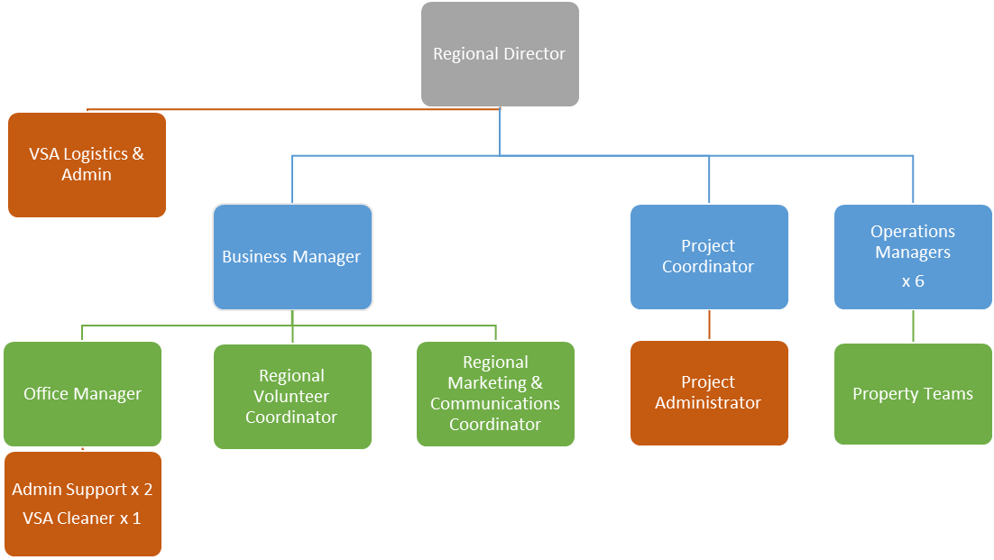

Operational considerations

* Due to the geographic spread of the portfolio, irregular travel can be required.  This will be on land, over sea, and by air as appropriate.  Accordingly, the post-holder must be comfortable with using cars, travelling by scheduled ferries and chartered boats, and by planes.
* Due to the geographic spread of the portfolio, duration of journeys, and the timetabling/scheduling of transport, the post-holder can expect overnight stays of (on average) 1-3 nights’ duration on any trip.  On occasion, because of weather conditions, journeys and overnight stays can be extended.
* This post may require some weekend and evening working in the support of press or VIP visits and events.

# The Purpose, Context, Key Responsibilities, and Person Specification reflect the requirements of the job at the time of issue. The Trust reserves the right to amend these with appropriate consultation and/or request the post-holder to undertake any activities that it believes to be reasonable within the broad scope of the job or his/her general abilities.

**Applications**

Interested applicants should forward their Curriculum Vitae (CV) or an Application Form to the People Services Department (Applications) by email via workforus@nts.org.uk, by Sunday 3rd March 2024

Please ensure your CV includes your full name and contact details, the CV file sent to us should be titled your first initial and surname. When submitting your CV please state the position and job location of the vacancy you are applying for in the subject title or body of your email: For example "Gardener - Culzean"