|  |  |  |
| --- | --- | --- |
| Description: Description: cid:_com_android_email_attachmentprovider_1_4837_RAW@sec.galaxytab | Job Description |  |

|  |  |
| --- | --- |
| **Role:** Visual Merchandiser | **Department:** Commercial Enterprises  Corporate Services Directorate |
| **Reports to:** Head of Retail | Pay Grade: 4 Lower £30,239 - £33,279 pro-rata  plus Essential Business Car User allowance £3,800 pa |
| **Location:** Hybrid role, primarily in properties with time spent in the office flexible to home or local hub | **Type of Contract:** Full Time, Permanent, Start date 3rd June 2024 |

# JOB PURPOSE

The primary objective of the Visual Merchandiser role is to support the consistent delivery of excellent visual merchandising and sales floor standards across all sites. By working collaboratively with the property teams, the post holder will ensure that our shops are displaying products in an exciting and enticing way, with the ultimate goal of maximising retail sales and profit. This will be achieved through a combination of policy, procedure and guideline development, and hands on in-store support of implementation with the property teams, with the latter being the predominant focus of the role. This role also carries the responsibility of developing the visual merchandising strategy, which will play its part in the delivery of the retail strategy and communicating the retail vision within each property. As a part of the retail management team, this role is involved in planning and delivery of the retail strategy, ensuring the profitability of the retail business.

# KEY RESPONSIBILITIES AND ACCOUNTABILITIES

**Property support**

* Work alongside property colleagues to develop and implement the visual direction of all retail locations, ensuring a consistent application of our brand whilst appealing to the specific visitor demographic of each property.
* Support property teams to deliver a consistent visual merchandising look and feel, creating appealing and eye-catching product displays, through hands on support and coaching where required.
* Working collaboratively with the property teams, manage the application of all shop merchandising: either through onsite visits, working with property teams, or through issuing guidance for operational delivery.
* Decision making and problem solving on product locations, using expertise and initiative to maximise income and profits, while considering stock availability and ongoing management of displays.
* Identify VM training needs and work with the Organisation Development team to deliver appropriate training methods in a timely manner.
* Identify display equipment requirements, source appropriate solutions, and manage implementation in line with an agreed budget.
* Support the retail team with store refurbishments from design through to merchandising ahead of reopening.

**In store signage**

* Working with the marketing team, set and manage the creative direction of all in-store retail signage, telling the stories of our products and promoting deals that drive sales using consistent and on-brand signage.

**Policy and Procedure**

* Working collaboratively with the property teams and national retail team, develop and maintain visual merchandise policies, procedures and guidelines that ensure a consistent look and feel across all locations.
* Develop, monitor, and maintain effective training/toolkits.
* Provide advice and support to property teams on visual merchandising and ensure a regime of monitoring is introduced and monitored to drive consistent standards.
* Update policies/procedures to reflect any changes; to ensure the required legislative requirements are met with regards to Health & Safety etc.

**Product support**

* Work with the Product Managers and Merchandise Manager when developing new products and ranges by providing guidance on product to ensure consistency in look and feel, merchandising application and customer appeal.

**Strategy**

* Responsible for the development and implementation of Trust’s retail visual merchandise strategy.
* Contributes to the NTS retail strategy, specifically with the provision of market Trends/Insights analysis.

The normal day-to-day duties of this role are such that a criminal record check or membership of the PVG scheme is not required.

# REQUIRED QUALIFICATIONS, SKILLS, EXPERIENCE & KNOWLEDGE

**Qualifications**

* Driving Licence, valid for driving within the UK

**Experience/Essential requirements for this role**

* Proven experience showing a creative and innovative approach to visual merchandising.
* Evidence of a flair for product display.
* Excellent interpersonal, communication and influencing skills.
* Strong analytical skills and ability to interpret business, financial and trading data, and trends.
* Demonstrable problem-solving skills with the ability to think creatively to generate practical solutions to complex problems.
* Ability to manage deadlines and adhere to critical paths, whilst working autonomously.
* Understanding of retail processes and legislation.
* Intermediate level user of Microsoft Office products (including MS Excel).
* Ability to maintain team ethic and apply focus on agreed collective national strategy.
* Proven experience of planning and prioritising competing demands on time.
* Integrity.

**Desirable**

* Experience in a retail multi-site environment on a national scale.
* Experience of retail operations within Visitor Attraction environment.
* Experience of managing the merchandising aspect of retail refurbishments.
* Have a broad knowledge of the geography of Scotland.

**DIMENSIONS AND SCOPE OF JOB**

**Scale**

* Responsible for creating policies and guidelines that set the creative direction of the shop look and feel for all retail locations, covering 47 shops and delivering sales of c.£7m per annum.
* Responsible for supporting the implementation of VM policies and guidelines across all retail locations.

**People Management**

* The post holder must be able to influence and communicate with key internal stakeholders to maximize retail income through effective store layout and range development.
* The post holder must be able to influence and communicate with key external stakeholders, such as product and equipment suppliers to ensure best value is gained.
* The Visual Merchandiser’s role is a pivotal function in the national retail department within Commercial Enterprises, providing direct support to all NTS properties.
* This role also has a close working relationship with the marketing team ensuring that retail point of sale is developed to tell the stories of our products and promote deals that drive sales.

**Finance Management**

* This role is not a budget-holder but has delegated responsibility for spend on visual merchandise equipment and point of sale, c. £20k p.a.

**Tools/equipment/systems**

* Uses the Midas System (or equivalent retail stock management and reporting systems) to sales performance and stock levels.
* Uses the finance system (MS Dynamics or equivalent) to order and receipt any equipment that is purchased.
* Intermediate user of Excel for analysis purposes.

**Workplace context**

* This role is predominantly field based. The post holder will be required to travel frequently to other locations on Trust business. (Note that as the Trust’s properties are often in remote or rural locations where public transport may be limited, the ability and confidence to drive in the UK is essential, and there may be a requirement to travel to our island properties which is usually by boat, or occasionally by airplane or helicopter).
* When not working in a property this is a hybrid role which can be managed from home and the central office location flexibly.

**Heritage Knowledge and Understanding:**

* Has an overview understanding of all aspects of conservation at the Trust and in particular at the properties. Has a working knowledge of the heritage character and profile of the properties.

**NTS Strategy knowledge:**

* Has a sound understanding of the Trust’s Core Purpose; Guiding Principles; Vision; Strategic Objectives and Priorities

**Example key performance indicators and targets**

* This role is critical in the delivery of the retail KPI’s:
  + Sales of c£7m p.a.
  + Gross profit margin of c.52%, £3.5m p.a.
  + Customer experience, measured via mystery visits.

**The Key Responsibilities, Scope of Job, and Required Qualifications, Skills, Experience & Knowledge reflect the requirements of the job at the time of issue. The Trust reserves the right to amend these with appropriate consultation and/or request the post-holder to undertake any activities that it believes to be reasonable within the broad scope of the job or his/her general abilities.**

**Retail Team Structure Chart**

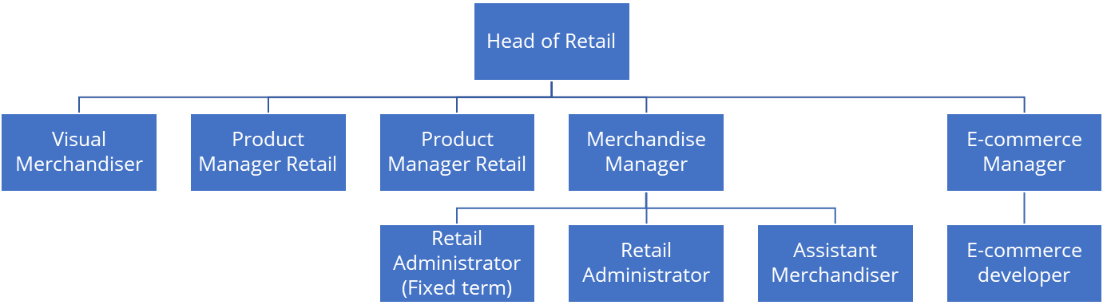

**Applications**

Interested applicants should forward their Curriculum Vitae (CV) or an Application Form to the People Services Department (Applications) by email via workforus@nts.org.uk, by Sunday 17th March 2024

Please ensure your CV includes your full name and contact details, the CV file sent to us should be titled your first initial and surname. When submitting your CV please state the position and job location of the vacancy you are applying for in the subject title or body of your email: For example "Gardener - Culzean"