 | Job Description | May 2024

Role: Fundraising Executive - Special Events | Business: Audiences & Support
Reports to: Fundraising Manager - Operations | Pay Band/Starting Salary: Grade 4 Upper £36,469 - £40,342 pro-rata, per annum
Location: Hermiston Quay, Flexible/Hybrid options available | Type of Contract: Permanent/ Full-time (40 Hours per week)

JOB PURPOSE

The Fundraising Executive – Special Events is responsible for planning, organising and executing a programme of events which enable the National Trust for Scotland to engage donors and prospective donors to generate funds for our charity.

The postholder works across the fundraising team to develop and deliver a calendar of flagship fundraising events, on- and off-line, across the different income streams contributing to our £10m+ annual fundraising target.

The role liaises with colleagues at properties, external speakers, external venues and suppliers to provide the highest quality events and stewardship through a varied programme, catering to our various target audiences and their specific interests and requirements.

It works with colleagues within the fundraising team, the Audiences & Supporter Directorate, the wider organisation and external stakeholders. This includes on occasion working with appointed agencies which will provide outsourced support to the Fundraising function.

KEY RESPONSIBILITIES AND ACCOUNTABILITIES

Events Executive

- Supporting the Fundraising Manager – Operations you will work across the Fundraising team to develop and implement a programme of events which fulfils outreach requirements, inspires and engages supporters, and showcases our charity and the activity we undertake to protect Scotlands’ heritage.
- Taking a proactive approach, nurturing strong relationships internally and externally to deliver events to a high standard.
- Work closely and collaboratively with other members of the Fundraising team to ensure a coordinated and consistent approach to capital campaigns and fundraising activity.
- Work with colleagues to ensure fundraising and cultivation events deliver the fundraising strategy and provide appropriate opportunities to showcase our work and engage support
- Provide the Fundraising Manager - Operations with accurate information for planning, budget preparation, forecasting, phasing and monitoring expenditure

- Develop positive and productive working relationships with fundraisers, senior leadership and other relevant internal stakeholders.
- Maintain and enhance your personal knowledge, skills and networks by playing an active role in the appropriate professional bodies and internal organisational groups.
- You’ll be flexible, with a willingness to work non-traditional hours and be available to travel in the UK.

REQUIRED QUALIFICATIONS, SKILLS, EXPERIENCE & KNOWLEDGE
The above outlines the key skills the job holder will need to possess and exercise. In addition, either knowledge of or experience in the following is required:

Essential skills
- Results oriented self-starter
- Team player, able to both respect and work across boundaries.
- Outstanding interpersonal and communication skills including active listening, negotiating, high levels of tact and significant ability to influence beyond authority.
- Ability to adopt a strategic and creative approach to event planning and delivery.
- Analytical problem solver with ability to generate and encourage new ideas.
- Strategic thinker with ability to set a plan and see it through to delivery.
- Excellent organisational skills and the ability to resolve conflicting priorities.
- Ability to manage resources efficiently for maximum impact.
- An eye for detail and a rigorous approach to process.
- A lively interest in and understanding of the National Trust for Scotland, and a passionate belief in its mission.

Essential Experience
- A track record of developing and delivering high quality events, both online and in-person.
- Experience of working with and influencing senior staff and senior external figures.
- Experience of working in a results driven environment, delivering success against key targets.
- Experience of the systems and processes necessary to underpin successful events management including Microsoft Office products and CRM systems.
- Ability to be flexible, with a willingness to work non-traditional hours and be available to travel in the UK.
- A current valid driving licence for driving in the UK.

Desirable skills
- Event Management Qualification

DIMENSIONS AND SCOPE OF JOB

People Management
- No line management responsibility
- You’ll work closely with other team members to ensure a co-ordinated and consistent approach to all fundraising activity.
- Builds strong relationships across the Audiences & Support Directorate, and across the Trust.

External Relationships:
- You will have regular contact with existing and potential supporters of our cause.
- You’ll have contact with appointed agencies and suppliers.

Financial Management
- Responsible for keeping and delivering accurate records and financial reports for all events
- Responsible for supporting the Fundraising Manager - Operations in budget planning and reporting.

Tools / equipment / systems
- Microsoft Dynamics
- Excel
- Microsoft Teams
- Zoom
Example key performance indicators and targets
- Meeting targets for income and activity
- Increase in philanthropic prospects and income.

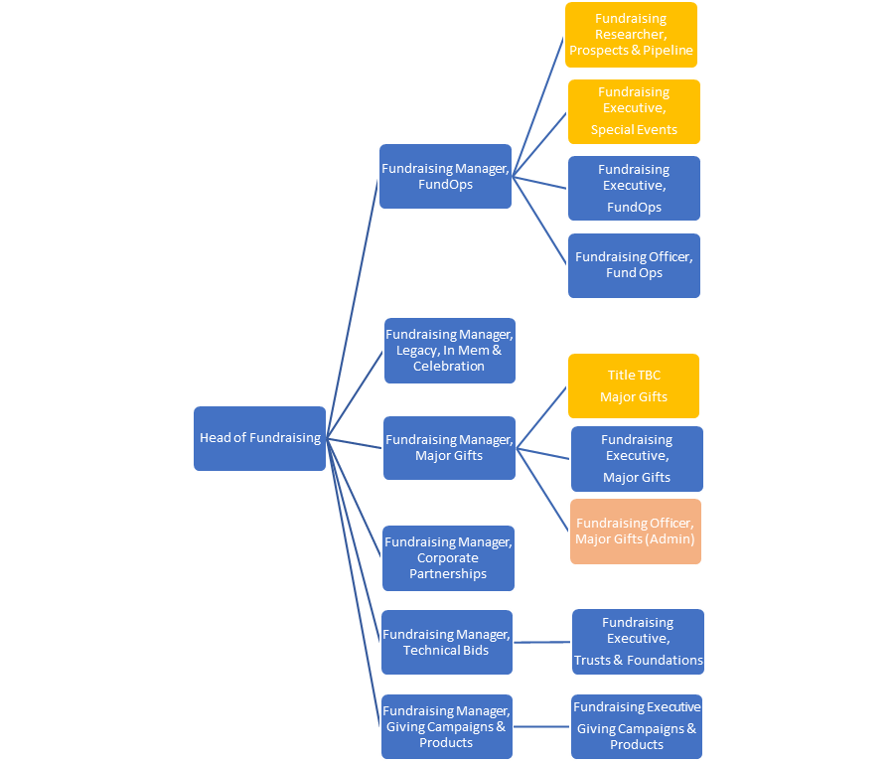

The Purpose, Context, Key Responsibilities, and Person Specification reflect the requirements of the job at the time of issue. The Trust reserves the right to amend these with appropriate consultation and/or request the post-holder to undertake any activities that it believes to be reasonable within the broad scope of the job or his/her general abilities.

Applications
Interested applicants should forward their Curriculum Vitae (CV) or an Application Form to the People Services Department (Applications) by email via workforus@nts.org.uk, by Sunday 26th May 2024
Please ensure your CV includes your full name and contact details, the CV file sent to us should be titled your first initial and surname. When submitting your CV please state the position and job location of the vacancy you are applying for in the subject title or body of your email: For example "Gardener - Culzean"

