|  |  |  |
| --- | --- | --- |
|  | **Job Description** | May 2024 |

|  |  |
| --- | --- |
| **Role:** Fundraising Manager, Major Gifts | **Business** Audiences & Support |
| **Reports to:** Fundraising Manager – Major Gifts | Pay Band/Starting Salary: Grade 5 Lower, £39,521 - £43,541 pro-rata, per annum |
| **Location:** Hermiston Quay, Flexible/Hybrid options available | **Type of Contract:** Permanent/ Full-time (40 Hours per week) |

**JOB PURPOSE**

The wider purpose of the role is to help drive the National Trust for Scotland’s ability to conserve Scotland’s built and natural heritage under its care.

The Fundraising Manager, Major Gifts will play an important role in the Fundraising team’s success, cultivating and soliciting major gifts for key activity and projects. As we approach our centenary and seek to increase our philanthropic income, the team’s ambitious income growth targets will rely on high level philanthropy.

You will work with colleagues within the fundraising team, the Audiences & Supporter Directorate, the wider organisation and, crucially, external stakeholders. You may on occasion work with appointed agencies which will provide outsourced support to the Fundraising function.

**KEY RESPONSIBILITIES AND ACCOUNTABILITIES**

The Fundraising Manager, Major Gifts will, with direction and support from the Fundraising Manager, Strategic Major Gifts, identify, cultivate and solicit major gifts from existing supporters and, critically, develop new networks of major donors to drive our charitable work.

**Major Gifts**

* With direction and support from the Fundraising Manager, Strategic Major Gifts you will develop the major gifts pipeline and take full responsibility for a portfolio of existing and potential major donors. You’ll adopt a proactive approach and will nurture strong relationships, develop and implement bespoke strategies for cultivation, solicitation and stewardship to negotiate and secure major gifts
* Act as a key point of contact for both major donors and major donor prospects
* Design and develop cultivation and stewardship plans for donors to ensure they are inspired, engaged, recognised and thanked appropriately
* Work with the Major Gifts team, Prospect Research Executive and wider team to develop and grow overall income and membership of Founders Circle and Patron’s Club, where this maximises fundraising income
* Work with the Strategic Major Gifts Manager to support the Head of Fundraising, CEO and wider executive team to develop relationships with key prospects and donors, providing insight and research to empower and inform discussions
* Fully participate and support prospect tracking meetings to deliver the implementation of customised solicitation plans, and ensure all relationships are recorded in our CRM system
* Work closely and collaboratively with other members of the Fundraising team to ensure a coordinated and consistent approach to capital campaigns and fundraising activity.
* Work with colleagues to ensure fundraising and cultivation events deliver the fundraising strategy and provide appropriate opportunities to showcase our work and engage support
* You will provide the Strategic Major Gift Manager with accurate information for planning, budget preparation, forecasting, phasing and monitoring expenditure
* Develop positive and productive working relationships with fundraisers, senior leadership and other relevant internal stakeholders.
* Maintain and enhance your personal knowledge, skills and networks by playing an active role in the appropriate professional bodies and internal organisational groups.
* You’ll be flexible, with a willingness to work non-traditional hours and be available to travel in the UK.

**REQUIRED QUALIFICATIONS, SKILLS, EXPERIENCE & KNOWLEDGE**

The above outlines the key skills the job holder will need to possess and exercise. In addition, either knowledge of or experience in the following is required:

Essential skills

* Results oriented self-starter
* Team player, able to both respect and work across boundaries.
* Outstanding interpersonal and communication skills including active listening, negotiating, high levels of tact and significant ability to influence beyond authority.
* Ability to adopt a strategic and creative approach to donor planning and approaches
* Strong writing ability with capacity to adapt from storytelling to concise and clear gift intention drafting.
* A high level of comfort delivering the ‘face to face’ ask
* Analytical problem solver with ability to generate and encourage new ideas.
* Strategic thinker with ability to set a plan and see it through to delivery.
* Gravitas; credible as a representative of our charity to high level philanthropists.
* Excellent organisational skills and the ability to resolve conflicting priorities.
* Ability to manage resources efficiently for maximum impact
* An eye for detail and a rigorous approach to process
* A lively interest in and understanding of the National Trust for Scotland, and a passionate belief in its mission.
* Essential Experience
* A track record of securing philanthropic gifts between four and six figures in person and sustaining a portfolio of fruitful relationships with donors
* Experience of working with and influencing senior staff and senior external figures.
* A track record of engaging colleagues in donor cultivation and proposal development in order to solicit a gift or report on a project, including the Chair, CEO and senior volunteers
* Experience of working in a results driven environment, delivering success against key targets
* Experience of the systems and processes necessary to underpin successful fundraising including Microsoft Office products and CRM system
* Ability to be flexible, with a willingness to work non-traditional hours and be available to travel in the UK
* A current valid driving licence for driving in the UK

Desirable skills

* Institute of Fundraising membership
* Experience of international fundraising

**DIMENSIONS AND SCOPE OF JOB**

**People Management**

* No line management responsibility
* You’ll work closely with other team members to ensure a co-ordinated and consistent approach to all fundraising activity.
* Builds strong relationships across the Audiences & Supporter Directorate, and across the Trust.

**External Relationships:**

* You will have regular contact with existing and potential supporters of our cause.
* You’ll have contact with appointed agencies and suppliers.

**Financial Management**

* Responsible for keeping and delivering accurate records, supporting the Major Gifts Manager in budget planning and reporting.

**Tools / equipment / systems**

* Microsoft Dynamics
* Excel
* Microsoft Teams
* Zoom

**Example key performance indicators and targets**

* Meeting targets for income and activity
* Development and maintenance of healthy prospect pipelines across projects and themes to help maximise fundraising potential.
* Increase in philanthropic prospects and income.

**Applications**

Interested applicants should forward their Curriculum Vitae (CV) or an Application Form to the People Services Department (Applications) by email via workforus@nts.org.uk, by Sunday 16th June 2024

Please ensure your CV includes your full name and contact details, the CV file sent to us should be titled your first initial and surname. When submitting your CV please state the position and job location of the vacancy you are applying for in the subject title or body of your email: For example "Gardener - Culzean"

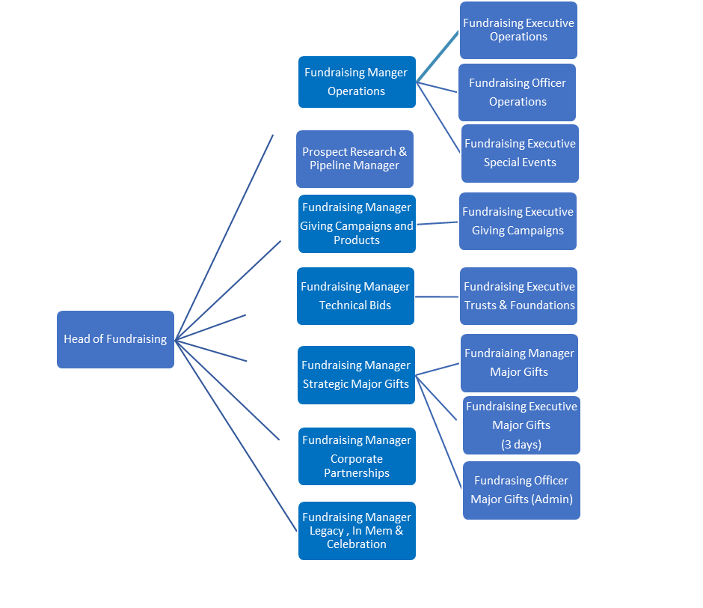

# The Purpose, Context, Key Responsibilities, and Person Specification reflect the requirements of the job at the time of issue. The Trust reserves the right to amend these with appropriate consultation and/or request the post-holder to undertake any activities that it believes to be reasonable within the broad scope of the job or his/her general abilities.

**Applications**

Interested applicants should forward their Curriculum Vitae (CV) or an Application Form to the People Services Department (Applications) by email via workforus@nts.org.uk, by Sunday 16th June 2024

Please ensure your CV includes your full name and contact details, the CV file sent to us should be titled your first initial and surname. When submitting your CV please state the position and job location of the vacancy you are applying for in the subject title or body of your email: For example "Gardener - Culzean"