 | Job Description | May2024

Role: Fundraising Researcher, Prospects and Pipeline | Business Audiences and Support
Reports to: Fundraising Manager - Operations | Pay Band/Starting Salary: Grade 5 Lower, £39,521 - £43,541 pro-rata, per annum
Location: Hermiston Quay, Flexible/Hybrid options available | Type of Contract: Permanent/ Full-time (40 Hours per week)

JOB PURPOSE
The Fundraising Researcher, Prospects and Pipelineis responsible for undertaking prospect and market research activities to drive the identification, qualification and due diligence of five, six and seven figure donors for the Trust. The postholder will play an important role in the Fundraising team’s success by supporting an insight-led approach to our fundraising taking full account of the Data Protection Act and GDPR.
. The Researcher, Prospects and Pipelinerecommendations will empower fundraisers and senior leadership to make informed and strategic, donor-centric decisions throughout our wider work. The majority of this role will be weighted towards philanthropist prospect research, with corporate and trust specific research as required.

You will work with colleagues within the fundraising team, the Audiences & Support Directorate and with the wider organisation. You may on occasion work with appointed agencies which will provide outsourced support to the Fundraising function, and play a key role in database development and support.

KEY RESPONSIBILITIES AND ACCOUNTABILITIES

Prospect Research
- Lead on the development and maintenance of healthy prospect pipelines across the team to help maximise and strategically focus the team’s fundraising potential.
- Develop and ensure quality control of prospect research processes and documentation.
- Conduct thematic and project led prospect research to identify quality prospects that align with the Trust’s strategic aims and project offering.
- Conduct network mapping of key internal and external individuals to support the engagement and cultivation of new and existing prospects.
- Qualify and prioritise prospective donors on behalf of the team.
- Develop and maintain prospect pipelines across income streams, assigning canvassers and ensuring healthy moves management for broadening our donor pool.
- Develop our due diligence framework and implement on all qualified prospects, undertaking full ethical checks where required in line with the Trust’s ethical checks policy.
- Produce research profiles and biographical briefings for events.
- Utilise internal and external prospect research databases and resources to aid prospect identification. Utilise a matrix and ratings approach to qualify prospects based on their capacity, affinity and access criteria.
- Help to identify events that members of the team can attend in a networking and/or insight gathering perspective.
- Recommend appropriate and cost-effective research tools and support the Fundraising Operations Manager to manage this as part of the expenditure budget.
- Develop positive and productive working relationships with fundraisers, senior leadership and other relevant internal stakeholders.
- Contribute to CRM management and development within Fundraising Operations and the wider team
- Maintain and enhance your personal knowledge, skills and networks by playing an active role in the appropriate professional bodies and internal organisational groups.
- You’ll be flexible, with a willingness to work non-traditional hours and be available to travel in the UK.

Market Insight
- Remain informed of key UK and European market trends within philanthropic and foundations sectors which may impact our prospect identification and qualification.
- Provide market intelligence when required to support Managers in strategic fundraising planning and implementation.

Compliance
- Maintain up to date knowledge and understanding of the Data Protection Act, GDPR and ICO guidelines, and any other relevant legislation and guidelines and their impact on fundraising.
- Support the team to embed best practice in all areas related to compliance, ensuring the effectiveness and accuracy of processes in accordance with the Data Protection Act, GDPR and other applicable legislation or regulation.

REQUIRED QUALIFICATIONS, SKILLS, EXPERIENCE & KNOWLEDGE
The above outlines the key skills the job holder will need to possess and exercise. In addition, either knowledge of or experience in the following is required:

Essential skills
- Proven track record of identifying five and six figure individuals and organisational prospects who are subsequently converted to donors and partners.
- Excellent understanding of the role of research in good prospect management, cultivation and stewardship.
- Strong organisational skills and experience of developing prospect research frameworks and processes across a broad-based fundraising team.
- Experience conducting prospect research using a range of relevant databases and research tools.
- Experience conducting network mapping of prospective individual and organisation partners.
- Confident self-starter with the ability to work under own initiative to meet agreed objectives and deliverables.
- Excellent research and analytical skills, including the ability to translate complex information and communicate it clearly and credibly to a range of stakeholders.
- Good knowledge and applied understanding of GDPR implications, ethical checks and other related compliance issues with regards to fundraising.
- Excellent verbal and written communication skills.
- Excellent attention to detail.
- Excellent organisational and time management skills, with the ability to effectively manage competing priorities and deadlines.

Desirable skills
- Experience of working in a not-for-profit organisation.
- A lively interest in and understanding of the National Trust for Scotland, and a passionate belief in its mission.

DIMENSIONS AND SCOPE OF JOB

People Management
- No line management responsibility
- You’ll work closely with other team members to ensure a co-ordinated and consistent approach to all fundraising activity.
- Builds strong relationships across the Audiences & Support Directorate, and across the Trust.
- External Relationships: You’ll have frequent contact with appointed agencies and suppliers.

Financial Management
- Responsible for recommending research tools and opportunities, supporting the Head of Fundraising and Fundraising Managers in budget planning.

Tools / equipment / systems
- Microsoft Dynamics
- Excel
- Microsoft Teams
- Zoom
Example key performance indicators and targets
- Developing and implementing prospect research framework, matrix and process.
- Development and maintenance of healthy prospect pipelines across projects and themes to help maximise and strategically focus the team’s fundraising potential.
- Increase in philanthropic prospects and income.

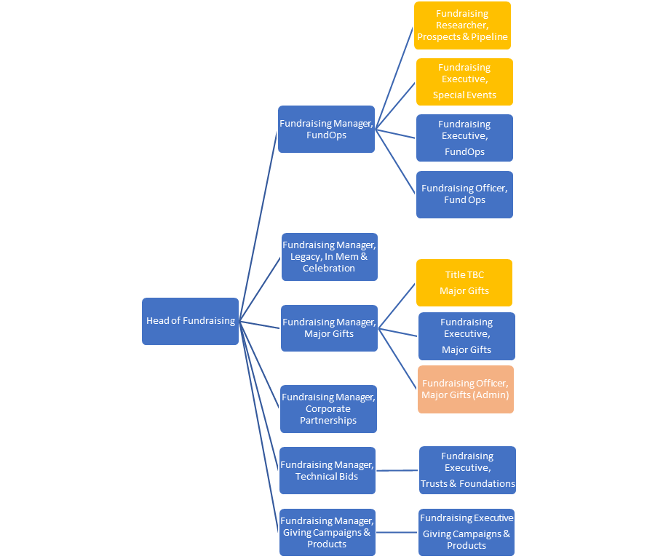

The Purpose, Context, Key Responsibilities, and Person Specification reflect the requirements of the job at the time of issue. The Trust reserves the right to amend these with appropriate consultation and/or request the post-holder to undertake any activities that it believes to be reasonable within the broad scope of the job or his/her general abilities.

Applications
Interested applicants should forward their Curriculum Vitae (CV) or an Application Form to the People Services Department (Applications) by email via workforus@nts.org.uk, by Sunday 16th June 2024
Please ensure your CV includes your full name and contact details, the CV file sent to us should be titled your first initial and surname. When submitting your CV please state the position and job location of the vacancy you are applying for in the subject title or body of your email: For example "Gardener - Culzean"

