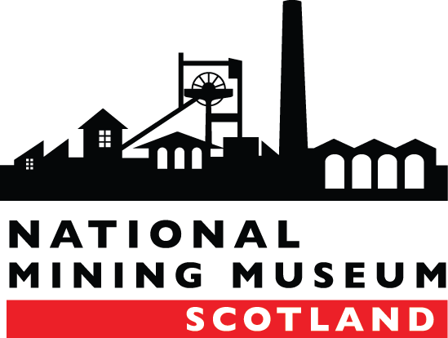

**NATIONAL MINING MUSEUM SCOTLAND**

|  |  |
| --- | --- |
| **JOB DESCRIPTION** | |
| **Post Title:** | Facilities Manager |
| **Salary:** | £29,000 pa (increased to £31,000 after probation period) |
| **Contract:** | Full Time (35hrs) |
| **Reports to:** | Chief Executive |
| **Responsible for:** | Technical Assistant and Cleaning staff. |

**BACKGROUND**

National Mining Museum Scotland is an independent trust and the national body responsible for the preservation and interpretation of Scotland’s Mining Heritage. The museum holds collections of national significance and is on the site of the Lady Victoria Colliery, built in 1895 as Scotland’s first super-pit. The museum offers a wide range of activities and events to a diverse and growing audience. The visitor experience includes access to the collections through tours and exhibitions and an award-winning education programme.

**JOB PURPOSE**

Overall responsibility for Property Management, Health and Safety, Fire Safety, Security and Maintenance of the National Mining Museum Scotland’s estate. To develop and work to standards which ensure best sustainability, safety and economies of scale which are achieved across facilities management. Ensure compliance with statutory legislation and NMMS policies and procedures, including data protection and health and safety. Responsibility for managing NMMS external contracts and tenants and the Facilities management budget. Liaise with NMMS’s expert partner Bruce Stevenson in all matters relating to health & safety and environmental management.

**KEY RESPONSIBILITIES**

1. Responsible for coordinating the National Mining Museum Scotland’s Health and Safety audit, reporting and training and improvement plan and Fire Risk Assessment management.
2. Respect and be aware of the requirements of managing and safeguarding a ‘Grade A’ listed building.
3. Establish and maintain an audit of the National Mining Museum Scotland’s property (fixed and moveable) and related assets.
4. Manage the National Mining Museum Scotland’s buildings security arrangements to Government Indemnity Scheme standards. You will be a key holder and oversee out-of-hours external security contracts (such as G4S), and work with Site Managers and appropriate staff, ensuring daily security compliance across the site.
5. Liaise with Bruce Stevenson (NMMS partner) for advice and support on matters relating to Health and Safety and Fire Safety.
6. Manage the NMMS approved contractors list ensuring quality and value for money.
7. Liaise with external partners and stakeholders with regard to the long-term maintenance of the site, such as Historic Environment Scotland and Midlothian Council.
8. Assist colleagues in the procurement of, logging of and training for any specialist equipment, including the *working at height* equipment.
9. Responsible for the management of the National Mining Museum’s tenants’ contracts, including general liaison and site visits.
10. Responsible for setting up and coordinating the National Mining Museum’s *Sustainability Action Plan* to reduce environmental impact, with specific responsibility for energy, water, properties, including training, monitoring, reporting and procurement.
11. Assist with the management of NMMS capital development projects, in particular the procurement of contractors.
12. Oversee the technical requirements for the installation and display of exhibitions and related activities at NMMS.
13. Work with the Chief Executive and the Curatorial Team to ensure that the conservation and heritage of the NMMS estate is subject to appropriate care and standards of presentation, and that conservation and heritage requirements are identified and incorporated in the NMMS Management Plan.
14. Ensure that the Technical and cleaning staff are well managed and clear on their objectives, given the opportunity to develop and receive regular feedback and performance appraisals.
15. Manage the Technical volunteers and ensure their contribution is focused and recognised.
16. Work closely with the Visitor Services Team to ensure that the customer experience is excellent through good presentation of facilities, cyclical maintenance programme and quick response to facilities issues.
17. Work with Visitor Services Team to ensure the suitable environment for events and activities, including where appropriate, the setting up of rooms for functions.

**PERSON SPECIFICATION**

|  | Essential | Desirable | Measured by |
| --- | --- | --- | --- |
| **Qualifications** | | | |
| Recognised Health & Safety qualification, certificate level e.g. IOSH, CITB or NEBOSH |  | x | Certificate to be produced at Interview |
| **Experience** | | | |
| Experience in museum/visitor attraction or similar environment. | x |  | Application form; interview questions; |
| Have an understanding of the requirements and responsibility of working in a Museum setting in particular in relation to the care of the museum collections. |  | x | Application form; interview questions; |
| Experience or a working understanding of the regulations surrounding listed buildings maintenance |  | x | Application form; interview questions; |
| Experience in solid understanding of implementing and managing health and safety policies and procedures | x |  | Application form; interview questions; |
| Experience in managing external contractors and coordinating access to the estate | x |  | Application form; interview questions; |
| Experience in managing budgets |  | x | Application form; interview questions; |
| **Skills and Attributes** | | | |
| Ability to be well organised and have strong planning and problem solving skills | x |  | Application form; interview questions; probation period |
| Experience in project management. |  | x | Application form; interview questions; probation period |
| Excellent communication skills, interpersonal, written and verbal | x |  | Application form/ interview questions |
| Proven IT skills in word processing, databases, spreadsheets & web/internet. |  | x | interview questions; probation period |
| Ability to influence and negotiate | x |  | interview questions; probation period |
| Highly motivated individual, able to meet tight deadlines and to manage workload priorities. | x |  | interview questions; probation period |
| Ability to be part of the museum’s management team and to help drive forward the museum’s strategic plan | x |  | interview questions; probation period |
| Ability to be a good team leader and to manage staff and volunteers. | x |  | Application form/ interview questions |
| **Other** | | | |
| Driving Licence. |  | x | To be produced at Interview |
| Flexible, able to work evenings, weekends and public holidays. | x |  | Interview questions; probation period |
| Be approachable and have a friendly disposition | x |  | Interview questions; probation period |
| Ability to work in a busy environment |  | x | Interview questions; probation period |